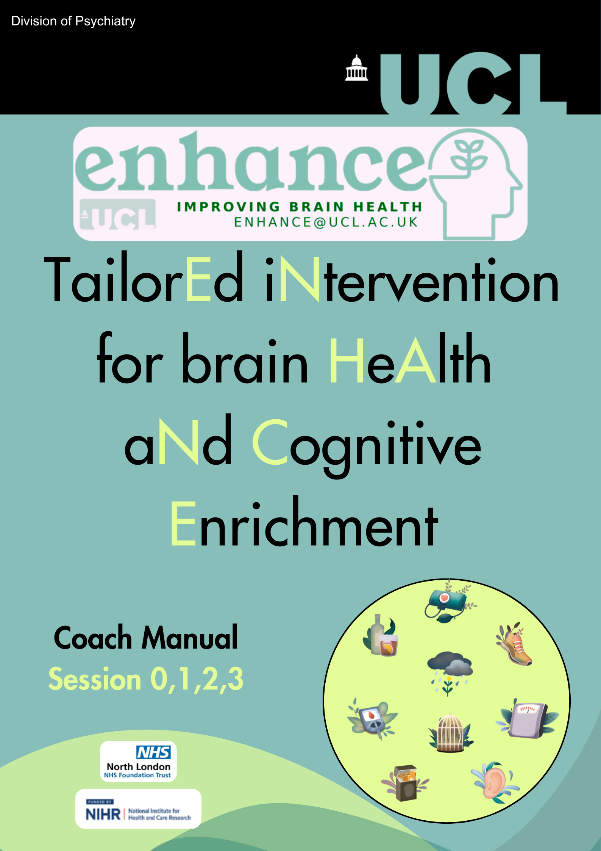9 sessions + onboarding



*(Tailor****E****d i****N****tervention for brain* ***H****e****A****lth a****N****d* ***C****ognitive* ***E****nrichment)*

**Coach Manual**

**Introduction & Onboarding (Session 0) and**

**Risk Factor Sessions 1, 2 and 3**

**Copyright © 2025 Sergi Costafreda Gonzalez and Gill Livingston.**

All Rights Reserved. These materials are for use only by authorised professionals involved in the research study and may not be shared, distributed, or used outside the study without explicit written permission from the research team. Unauthorised use is prohibited.

**Coaching Manual Contents**

Introduction 7

The Coaching Role: Overview 8

Coaching: The GROW Model 9

Coaching: Implementing Behaviour Change Techniques 10

Setting SMART Goals: 12

Displaying Coaching Skills in Sessions: 13

Coaching Sessions Overview 14

Onboarding Session (Session 0) 14

Session 1 and Beyond 14

ENHANCE Coaching Timeline 15

Coach Preparation 16

Onboarding Session (Session 0) [45 minutes – 1 hour] 17

1. Welcome and Introduction (5-10 minutes) 17

2. Feedback on Risk Factors (10-15 minutes) 17

**💬 Introduction to Feedback:** 17

**📊 Explanation of Risk Factors** 17

3. Choice of Risk Factors (10 minutes) 18

**🗣️ Encourage Participant Selection:** 18

**🔢 Choosing the Order** 18

**🗓️ Planning for Future Focus:** 18

**💡 Offering Suggestions if Unsure:** 19

**🔍 Insights into Interventions:** 19

4. App Setup & Usage (~10-15 minutes) 21

**Set-up summary checklist:** 21

5. Introduce Self-Monitoring [IF RELEVANT TO CHOSEN RISK FACTORS] 22

**Provision of Necessary Equipment** 22

**If Managing Blood Pressure or Getting Active is Chosen First:** 22

6. Set Key Tasks (15 minutes) 23

📱 **Task 1: Encourage Participant to Explore the App Independently** 23

**📊 Task 2: Introducing Self-Monitoring** 23

7. Closing and Next Steps (5 minutes) 23

Overview of Blood Pressure Intervention in ENHANCE 26

The Coaching Role: Managing Blood Pressure 26

Blood pressure readings in ENHANCE: 26

App Content: Managing Blood Pressure (For reference) 27

Managing Blood Pressure: Session 1 (30-60 minutes) 28

1. Check-In & Review (10-15 minutes) 28

2. Discussion on Managing Blood Pressure (20 minutes) 28

3. Set 1-3 Goals - Managing Blood Pressure (15-20 minutes) 29

4. Closing and Next Steps (5 minutes) 29

Managing Blood Pressure: Session 2-3 (~30 minutes) 30

1. Review the Participant’s Progress 30

2. Problem-Solving: 30

3. Next Steps: 30

Overview: Managing Blood Sugar Intervention 32

Coaching Role: Helping Engagement with GP Practice 32

App Content: Managing Blood Sugar (for reference) 33

Managing Blood Sugar: Session 1 (30-60 minutes) 34

1. Check-In & Review (10-15 minutes) 34

2. Discussion on Managing Blood Sugar (20 minutes) 34

3. Set 1-3 Goals - Managing Blood Sugar (15-20 minutes) 35

4. Closing and Next Steps (5 minutes) 35

Managing Blood Sugar Session 2 & 3 - Progress Check 36

1. Review the Participant’s Progress 36

2. Problem-Solving: 36

3. Next Steps: 36

Overview of the Quitting Smoking Intervention in ENHANCE 38

Quitting Smoking Plan in ENHANCE 38

The Coaching Role: Supporting Participants 38

App Content: Quitting Smoking (for reference) 39

Quitting Smoking: Session 1 (30-60 minutes) 40

1. Check-In & Review (10-15 minutes) 40

2. Setting a Quit Date & Developing the Quit Plan (20 minutes) 40

3. Set 1-3 Goals – Quitting Smoking (15-20 minutes) 41

4. Closing and Next Steps (5 minutes) 41

Quitting Smoking Session 2 & 3 – Progress Check 42

1. Review the Participant’s Progress 42

2. Problem-Solving: 42

3. Next Steps: 42

Overview of the Better Hearing Intervention 44

App Content: Better Hearing (for reference) 44

Better Hearing: Session 1 (30-60 minutes) 45

1. Check-In & Review (up to 20 minutes) 45

2. Discussion on Better Hearing (20 minutes) 45

3. Set 1-3 Goals – Better Hearing (15-20 minutes) 46

4. Closing and Next Steps (5 minutes) 46

Better Hearing: Session 2 & 3 - Progress Check 47

1. Review the Participant’s Progress 47

2. Problem-Solving: 47

3. Next Steps: 47

Overview of Getting Active Intervention in ENHANCE 49

The Coaching Role: Getting Active 49

App Content: Getting Active (for reference) 49

Getting Active: Session 1 (30-60 minutes) 50

1. Check-In & Review (10-15 minutes) 50

2. Discussion on Getting Active (20 minutes) 50

3. Set 1-3 Goals for Getting Active (15-20 minutes) 51

4. Closing and Next Steps (5 minutes) 51

Getting Active: Session 2 & 3 – Progress Check (30 minutes) 52

1. Review Progress 52

2. Problem-Solve 52

3. Next Steps 52

Overview of Healthy Eating Intervention in ENHANCE 54

The Coaching Role: Healthy Eating 54

App Content: Healthy Eating (for reference) 55

Healthy Eating: Session 1 (30-60 minutes) 56

1. Check-In & Review (10-15 minutes) 56

2. Discussion on Healthy Eating (20 minutes) 56

3. Set 1-3 Goals - Healthy Eating (15-20 minutes) 57

4. Closing and Next Steps (5 minutes) 57

Healthy Eating: Session 2 & 3 – Progress Check (~30 minutes) 58

1. Review the Participant’s Progress 58

2. Problem-Solve: 58

3. Next Steps: 58

Overview of Drinking Less Intervention in ENHANCE 60

The Traffic Light System in ENHANCE 60

The Coaching Role: Drinking Less 60

App Content: Drinking Less (for reference) 61

Drinking Less: Session 1 (30-60 minutes) 62

1. Check-In & Review (10-15 minutes) 62

2. Discussion on Alcohol Intake (20 minutes) 62

3. Set 1-3 Goals - Drinking Less (15-20 minutes) 63

4.Closing and Next Steps (5 minutes) 63

Drinking Less Session 2 & 3 – Progress Check (~30 minutes) 64

1. Review the Participant’s Progress 64

2. Problem-Solving: 64

3. Next Steps: 64

Overview of Meeting People Intervention in ENHANCE 66

The Coaching Role: Meeting People 66

App Content: Meeting People (for reference) 66

Meeting People: Session 1 (30-60 minutes) 67

1. Check-In & Review (10-15 minutes) 67

2. Discussion on Meeting People (20 minutes) 67

3. Set 1-3 Goals – Meeting People (15-20 minutes) 68

4. Closing and Next Steps (5 minutes) 68

Meeting People: Session 2 & 3 - Progress Check 69

1. Review the Participant’s Progress 69

2. Problem-Solving: 69

3. Next Steps: 69

Overview of Better Mood Intervention in ENHANCE 71

Intervention Components & The Coaching Role: 71

App Content: Better Mood (for reference) 72

Better Mood: Session 1 (30-60 minutes) 73

1. Review Participant’s Progress: 73

2. Check-In (10-15 minutes) 73

3. Discussion on Better Mood (20 minutes) 73

4. Set goals: 1-3 Activities for Better Mood (15-20 minutes) 74

5. Closing and Next Steps (5 minutes) 74

Better Mood: Session 2 & 3 – Progress Check (~30 minutes) 75

1. Review the Participant’s Progress: 75

2. Problem-Solving: 75

3. Next Steps: 75

Appendix 77

Additional Information for ENHANCE Risk Factors 84

2.1 Behaviour Activation List 84

2.2 Additional SMART Goals Suggestions 85

2.3 Helpful GROW Coaching Questions to Problem-Solve 93

2.4 Frequently Asked Questions (FAQs): 95

2.5 Goal Setting Template: 97

2.6 Quit Plan Template: 98

2.7 Participant Guide to ENHANCE Sessions: 99

# **Introduction**

This guide offers practical guidance for Coaches delivering the **ENHANCE programme**, aimed at helping Participants manage key risk factors to improve their overall wellbeing and brain health.

📑 **Purpose of the Guide**

* Provide **structured yet flexible** approaches to Coaching sessions.
* Empower the Participant to make **informed choices** about their health journey.

🤝 **Onboarding Session**

The **onboarding session** is uniform across all risk factors. Its goal is to:

* **Establish a strong foundation** for the Coaching relationship.
* Ensure the Participant is comfortable with the tools and resources provided.



🎯 **Follow-up Sessions**

Following the onboarding, sessions will:

* **Adapt** to the chosen risk factor.
* Vary in content and focus, depending on the Participant’s goals and chosen risk factors.

# **The Coaching Role: Overview**

As an ENHANCE Coach, you will help Participants reduce risk factors and improve their brain health. This section outlines key parts of your role guiding the Participant through the interventions.

🔄 **Randomisation**

* 📢 An ENHANCE researcher will tell you a Participant has been randomised to intervention.
* 📊 They will give you the Participant’s **baseline assessment results** and **contact details**.
* 🗓️ **Next Steps:** Contact the Participant within a week to arrange a suitable time for the first research session meeting.

🧠 **Role of the ENHANCE Coach**

Your role as an ENHANCE Coach is vital in helping the Participant to improve their brain health by addressing key risk factors for dementia. Here’s how you can make a lasting impact:

1. **Providing Guidance and Support**

* 🧭 Offer **personalised support** in one face-to-face meetings, then online and in SMS/email.

1. **Building Rapport**

* 🤝 Establish a **trusting relationship** with the Participant through empathy and understanding.

1. **Encouraging Behaviour Change**

* 💪Inspire and motivate the Participant to engage with the intervention and overcome personal obstacles.
* 🎯 Help them **set meaningful goals** and make **lasting lifestyle changes.**

1. **Setting Goals and Implementing Techniques**

* 📝Work with the Participant to set **achievable, measurable, personalised goals**.
* ⚙️ Use effective **behaviour change techniques (BCTs)** for goal attainment (see next page).

*If the Participant asks you at any point any medical questions, please refer them to their GP practice.*

# **Coaching: The GROW Model**

Coaching sessions often follow a structure called the GROW model, which helps guide conversations and support change. It can also work with other methods like **Motivational Interviewing** and using **Behaviour Change Techniques.**

# **Coaching: Implementing Behaviour Change Techniques**

As a Coach, you will be supporting the Participant to use Behaviour Change Techniques (BCTs). These are methods to help individuals change their thoughts, habits, and behaviours.

Below are examples of different BCTs to support the Participant to change their risk factor behaviour:

|  |  |
| --- | --- |
| **Goal Setting** | Help the Participant to set SMART goals (Specific, Measurable, Achievable, Relevant, Time-bound). |
| **Self-Monitoring** | Encourage the Participant to track and record their status to increase self-awareness (e.g., record blood pressure). |
| **Feedback** | Provide the Participant with positive feedback to reinforce changes in behaviour (e.g., being more active). |
| **Reinforcement** | Offer positive reinforcement as motivation to continue (e.g., small positive changes are just as important). |
| **Social Support** | Encourage the Participant to involve their friends and/or family by discussing the ENHANCE intervention, to provide support and assistance in achieving goals. |
| **Relapse Prevention** | Assist with developing strategies to anticipate and cope with lapses or setbacks with the behaviours. Suggestions to reduce BP, lifestyle changes. |
| **Action Planning** | Assisting the Participant to develop manageable and achievable steps and strategies to achieve their goals through the SMART framework. |
| **Problem-Solving** | You will track the Participant's progress via the Dashboard and regular chats. If challenges arise, you'll help them problem-solve and adjust their plan. |

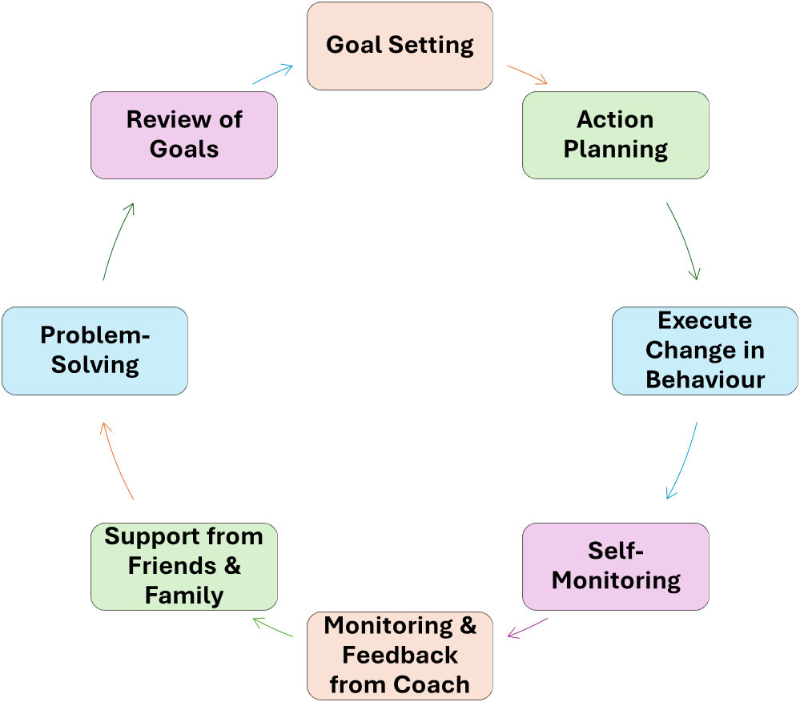

Figure 1. Participant Flow: Coach Support and Actions

# **Setting SMART Goals:**

You will help the Participant to set SMART goals which are clear, relevant and motivating. They help the Participant to take meaningful steps towards lifestyle changes that align with their values and abilities. Planning and visualising success are important parts of this process.

**SMART** Goals Framework:

**Specific** – you know exactly what you want to do

*Example: Instead of “I want to eat better”, try “I will buy 5 new healthy ingredients and cook two new recipes this week”*

**Measurable** – you can track progress and know when you’ve achieved it.

*Ask: How will you measure success? How will you know the goal is met?*

**Achievable** – make sure it’s realistic to you.

*Small wins build confidence. Check by asking: “On a scale of 1-10, how confident are you that you can achieve this?”*

**Relevant** – the goal should matter to you.

*Ask: Why is this important? How does it fit your values?*

*Tip: Use a scale of 1-10 to check how important it feels.*

**Time-Bound** – set a deadline to stay on track.

*Example: “I will achieve this goal in the next two weeks”. Break bigger goals into smaller weekly steps.*

# **Displaying Coaching Skills in Sessions:**

Example Coaching skills to adopt when delivering the Coaching sessions:

# **Coaching Sessions Overview**

## **Onboarding Session (Session 0)**

* **Purpose**: Use across risk factors to build rapport and set the foundations for the intervention
* ✅ **Tasks**:
  + 📊 Review the Participant’s risk factors.
  + 🎯 Help the Participant select up to three risk factors to focus on.
  + 📱 Introduce the app and ensure the Participant is comfortable using it, guiding them through setup and encouraging independent task completion.

***Coach note***: *This session is a* ***guide****. Some Participants may need more time, and it’s okay if everything isn’t covered in one meeting. Adjust based on the Participant’s needs.*

## **Session 1 and Beyond**

* **Focus**: Tailored to the Participant’s chosen risk factors.
* **Structure**:
  1. **Check in and review progress**: check on what’s going well and identify challenges.*Praise* each bit of progress, no matter how small. Acknowledge difficulties faced and offer problem-solving.
  2. **Discuss content:** Explore relevant app content related to the specific risk factor. Discuss the Participant’s understanding of the content, and address misconceptions.
  3. **Set goals:** Work with the Participant to set personalised, achievable goals related to the risk. Suggest potential goals if the Participant is unsure and ask what they would like to focus on.
  4. **Support and help to problem-solve:** Address any difficulties and provide guidance as needed. Offer a range of strategies and let the Participant choose the one that suits them best.
* **Build on Progress**: Each session builds on the last, focus on practical strategies and support.
* **Key Points:** Encourage active involvement in goal setting to choose actions that suit them best.
* **Flexibility:** Sessions are adaptable. Not all Participants will follow the same pace or structure, and the Coaching sessions should be adjusted to meet individual needs.

# **ENHANCE Coaching Timeline**

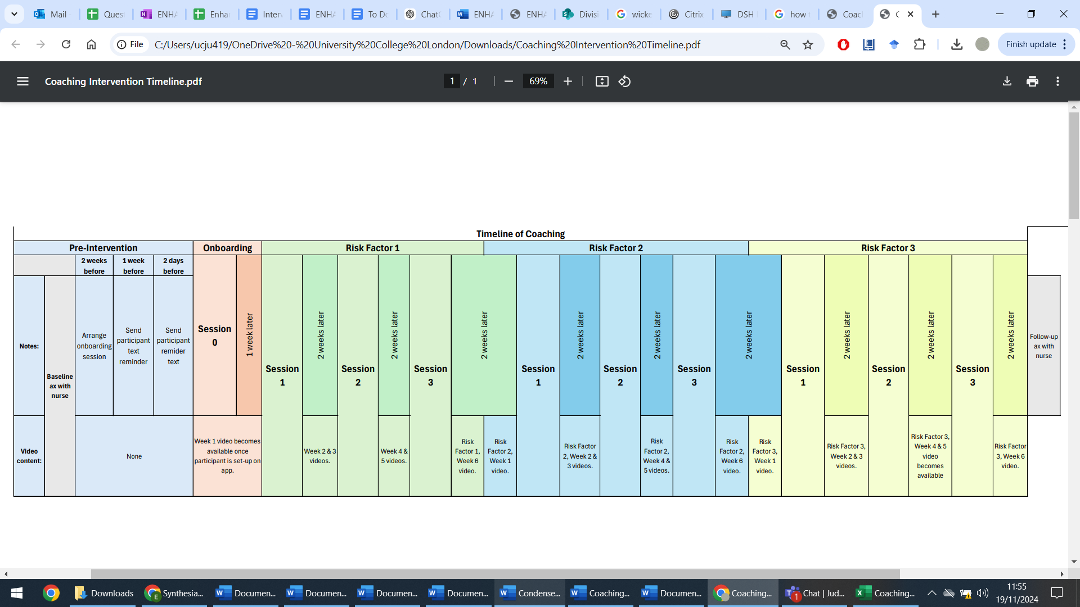

# **Coach Preparation**

**Send reminders to the Participant via email or SMS**

**ONE WEEK BEFORE:**

**Subject:** *Reminder: ENHANCE Coaching Session*

*Hi [Participant’s Name],*

*Just a quick reminder about your upcoming ENHANCE session on [date] at [time].*

*We’ll meet [location/online details]. Let me know if you have any questions.*

*Best,*

*[Coach’s Name]*

**2 DAYS BEFORE:**

**Subject:** ENHANCE Session Reminder

*Hi [Participant’s Name],*

*A quick reminder about our ENHANCE Coaching session on [date] at [time]. I’ll see you [location/online details].*

*Best,*

*[Coach’s Name]*

**ON THE DAY:**

**Subject**: ENHANCE Session Today

Hi [Participant’s Name],

Today’s the day! Just a reminder that we’ll be meeting at [time] [location/online details].

Looking forward to seeing you!

Best,

[Coach’s Name]

✅ Coach Checklist (Before first meeting):

1. 🔑**Ensure you have your login details to SealedEnvelope to complete Coach forms**.
2. ⏰ **Arrive early** or log on **5 minutes beforehand** to avoid delays. ***Coaching sessions can be done in person, on MS Team, or over the telephone.***
3. View the Participant’s activity on the **Dashboard**, check any activity & messages sent.
4. 🎤 **Have an audio recorder** ready, if relevant for the meeting.
5. 📞 **Keep the Participant’s phone number** and the research team’s contact details handy.
6. 📄 **Have the** main manual and intervention summary sheets accessible if needed.
7. 📱 **Bring a tablet** for the Participant to use for the duration of the trial
   * Ensure, if not done already by the core team, to increase the tablet font size, turn off screen time out, delete all default apps and place the ENHANCE app in the centre.
8. 🩺 **Have a BP monitor and pedometers** ready for blood pressure and physical activity.
9. 📝 Have the **completed summary of risk factors sheet** at hand to give to the Participant (Sheet in the Appendix if not).
10. ✔️ **If you have been told by the ENHANCE team to record this session,** let the Participant know you are recording, and if they object, do not record.

**Log In to SealedEnvelope Here**

[**SealedEnvelope.com/access**](http://www.sealedenvelope.com/access/)

*Press CTRL + click the link with the mouse to open*

# **Onboarding Session (Session 0) [45 minutes – 1 hour]**

****🤝 Build rapport, provide feedback, focus on understanding, motivation and readiness to change behaviour.

***Coach Note:*** *Everyone will vary; this is a rough guide on what can be covered.*

## **Welcome and Introduction (5-10 minutes)**

* **Build rapport and develop trust** with the Participant, explain your role as a Coach.
* **Explain the purpose** of the sessions and the app.

**Example:** *“Hi, I’m [Coach’s name], and I will be your Coach, supporting you and helping you with everything through ENHANCE. What would you like me to call you?*

*OK [Person’s name], so you saw the nurse recently, and you did some tests. What I would like to do today is talk to you about what we found, and what you can do about it. I am here to support you with the app and to help you improve your brain health.*

*So, the first thing I would like to do is show you a short summary of what we found. Would that be OK?”*

## **Feedback on Risk Factors (10-15 minutes)**

### **💬** Introduction to Feedback:

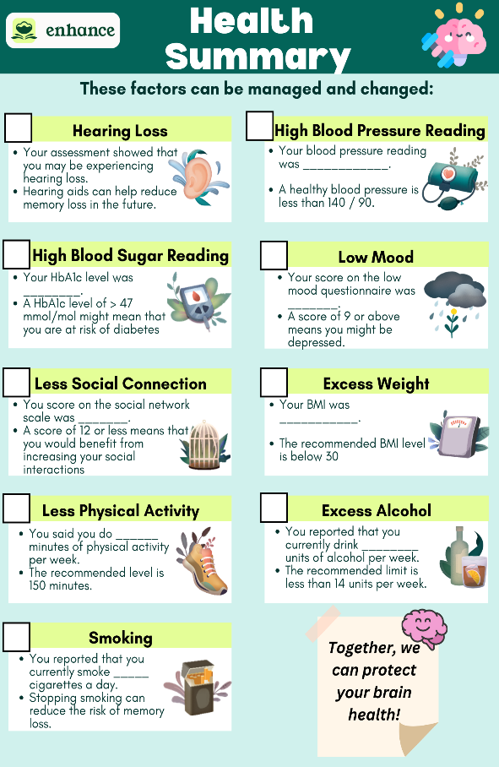

Figure 2. Health Status Summary for Participants

**Example: “**Let’s talk about the results from your assessment with the nurse. I’ll discuss each risk factor identified, I have a letter summarising everything, so you don’t need to remember it all.”

**Hand the Participant the Health Summary (Figure 2, see Appendix for printable copy)**

### **📊** Explanation of Risk Factors

Using the risk factor summary, give the Participant a brief and clear explanation of the results of each of their risk factors. Example: *“You have X number of factors that can be addressed…”*

**Encourage Participant Involvement:** After explaining each risk factor, invite the Participant to engage:

* **Ask: *“****Does this match what you were expecting? Do you have any questions?”*
* **If the conversation strays off-topic,** gently redirect: *“These are great questions, and we’ll be coming back to them in more detail during our future sessions. For now, let’s focus on choosing where you’d like to start.”*

*If the Participant asks you any medical questions, please explain that you are not medically trained and refer them to their GP practice.*

## **Choice of Risk Factors (10 minutes)**

### **🗣️** Encourage Participant Selection:

After discussing all their risk factors, ask the Participant to pick three they’d like to focus on and ask them to choose which one to work on first.

**Example: “***Now we have identified your risk factors, the next step is to decide which of these risk factors you would like to target in ENHANCE. Let’s think about how you might choose up to 3 risk factors”.*

* Explain that changing behaviour is best done one step at a time and that you will look at the top 3 risk factors they want to work on in ENHANCE and manage them one at a time.
* **If they are unsure**, focus on one and guide them with these questions (more guidance on the next page)
  + (a) “*Which one do you think might be easiest for you to start with?”*
  + *(b) “Which one do you feel ready to change right now?”*

### **🔢** Choosing the Order

**Example:** “*Now that we have selected 3 risk factors you want to focus on, the next step is to choose the order in which to address them.”*

|  |  |
| --- | --- |
| Order | Risk Factor Chosen by Participant |
| Risk Factor 1 |  |
| Risk Factor 2 |  |
| Risk Factor 3 |  |

### **🗓️** Planning for Future Focus:

* Once the first risk factor is selected, ask them to choose **two other risk factors to focus on later** in the intervention.

**Example**:

* + *“We’ll also select two other things to focus on later. We’ll talk more about those when the time comes, and remember, we can always adjust these choices if needed.”*
  + *“We’ll be discussing these choices in our meetings, and if you feel the need to change focus later on, that’s completely fine.”*

### **💡** Offering Suggestions if Unsure:

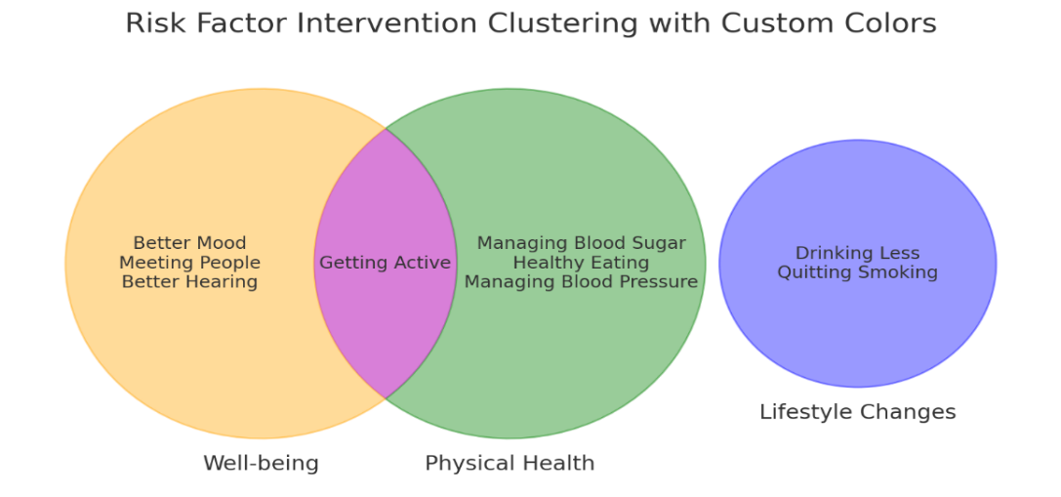

Figure 2. Clusters of Risk Factors in ENHANCE

* If they are still unsure, suggest **starting with a high-priority risk factor intervention** (e.g., Managing Blood Pressure or Managing Blood Sugar).
* **If they are indecisive and have low mood**, suggest focusing on low mood as it poses the highest risk at an individual level.
* Alternatively, suggest addressing risk factors interventions that cluster together as in Figure 3,

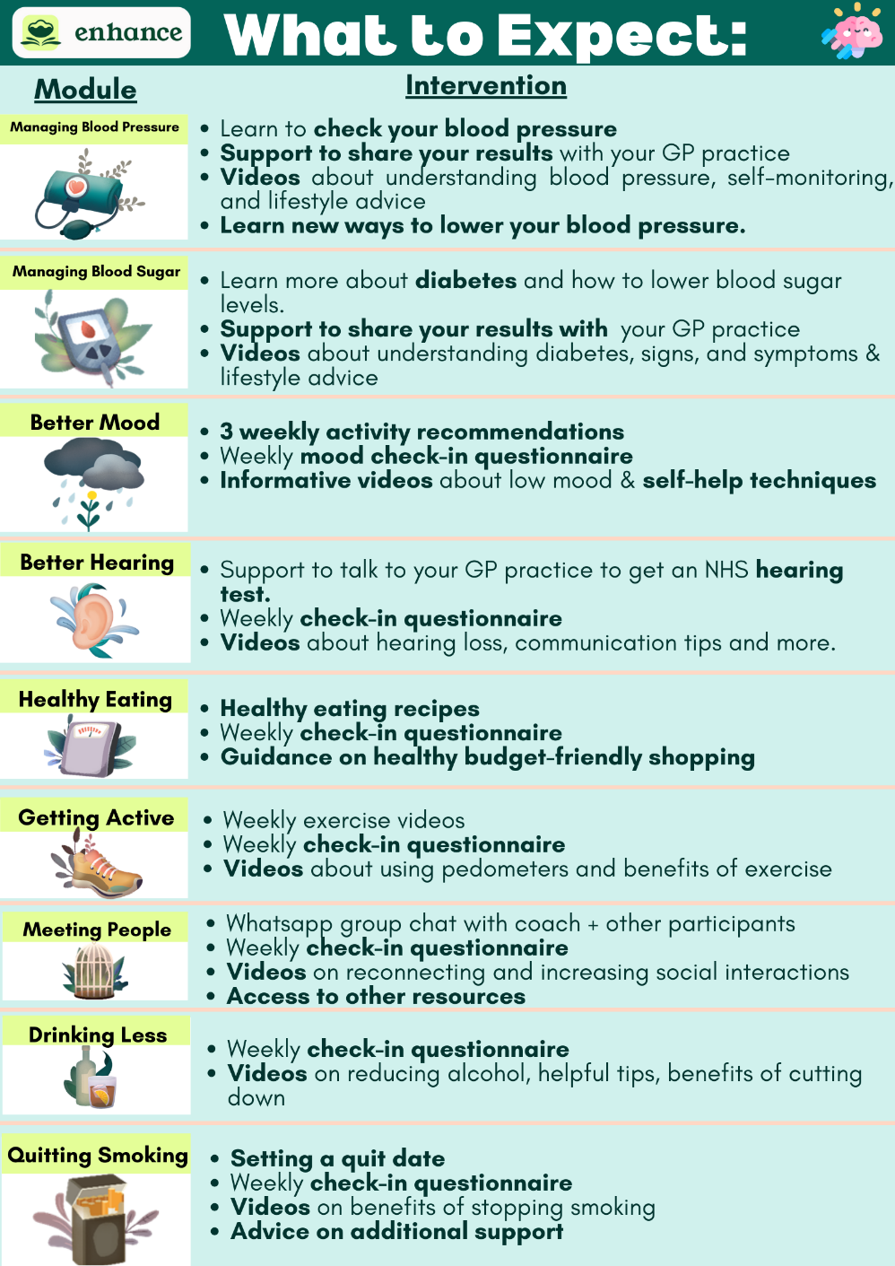

**Example***: “How do you feel about starting with Getting Active? Sometimes people find that addressing their activity levels might lower their blood pressure or blood sugar levels.”*

**Other suggestions:**

* One they think would be **easiest**.
* One they **particularly** **want** **to** address.
* One they feel could have the **most health benefit**.
* One they have **tried addressing before.**

### **🔍** Insights into Interventions:

If the Participant asks for more insight into what is provided within each risk factor intervention, then you can use this table to help them make an informed decision about their risk factors.

🗓️ Confirm Meeting Frequency: Discuss how often to meet and modality of the sessions (first session will be face-to-face, subsequent sessions remote via Teams or Telephone; prioritise Teams).

**Example:** *“We tend to meet people every two weeks, and in between the meetings, you can also message me through the app if you need to. If I am away, I will let you know who will be there instead.*

|  |  |  |
| --- | --- | --- |
| Meeting | Date & Time | Modality |
| Onboarding | [dd/mm/yyyy] hh:mm | Face-to-face |
| Risk Factor 1, Session 1 |  | Teams/Telephone (prioritise Teams) |
| Risk Factor 1 Session 2 |  | Teams/Telephone (prioritise Teams) |
| Risk Factor 1, Session 3 |  | Teams/Telephone (prioritise Teams) |

👨‍👩‍👧 Nominating a Friend or Relative:

Introduce the idea of nominating friends or family to support the Participant and to share their goals with.

* **Encourage the Participant to involve friends or family** in their lifestyle changes.

**Example**: *“Would you like to involve a family member or friend to keep you motivated? We can let them know how you are progressing, and they can encourage you. Most people find that helpful.”*

* If they say yes, gather **contact details** (first name, mobile number, and/or email address) of the friend or family member. Suggest this can be the first message on the app and explain that the ENHANCE team will get in touch with them and send **regular updates** (explain they can opt out if they wish).

**Example:** *“I’ll send them the same weekly summary updates that you’ll receive, so they can stay informed and encourage you.”*

## **4. App Setup & Usage (~10-15 minutes)**

### Set-up summary checklist:

* 📱 **Give tablet to participant:** Ensure the Participant is provided with one.
* **Invite the Participant to join ENHANCE via the Dashboard**
* **Encourage the Participant to independently perform tasks such as:**
  + Turning the tablet on & off, sending a message, unlocking the screen, adjusting the volume.
* 📱 **Assist with app download and setup (if not already done by ENHANCE core team):**
* 🎮 **Explore app features:**
  + Ask them if they would like to start trying out the games or exploring the features.
  + Introduce the concept of tokens (maximum of 10) and let the Participant play a few games.
    - Example: *“How about trying out one of the games now? You’ll earn seeds and it’s a fun way to get familiar with the app.”*
* 📄 **Review the app instruction leaflet:** Inform them about the leaflet and they can refer to it any time.
* 🗓️ **Agree on app usage goals:**
  + “*How about aiming to use the app a few times this week? Including watching some videos and playing some of the games. Does that sound manageable, or would you prefer a different goal?”*

**Coaches need to invite Participants to ENHANCE via the Dashboard and assign their risk factors.** Please see the **Dashboard guide and video tutorial** in the Teams channel.

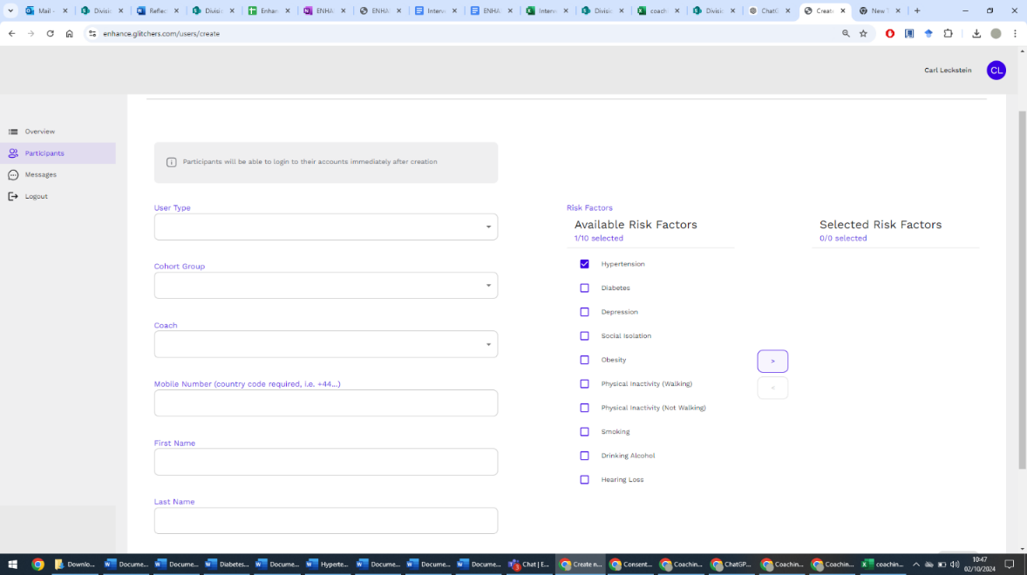

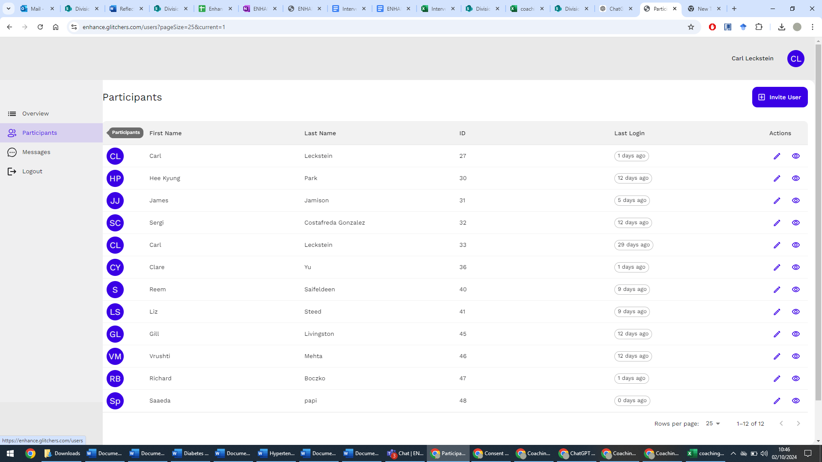

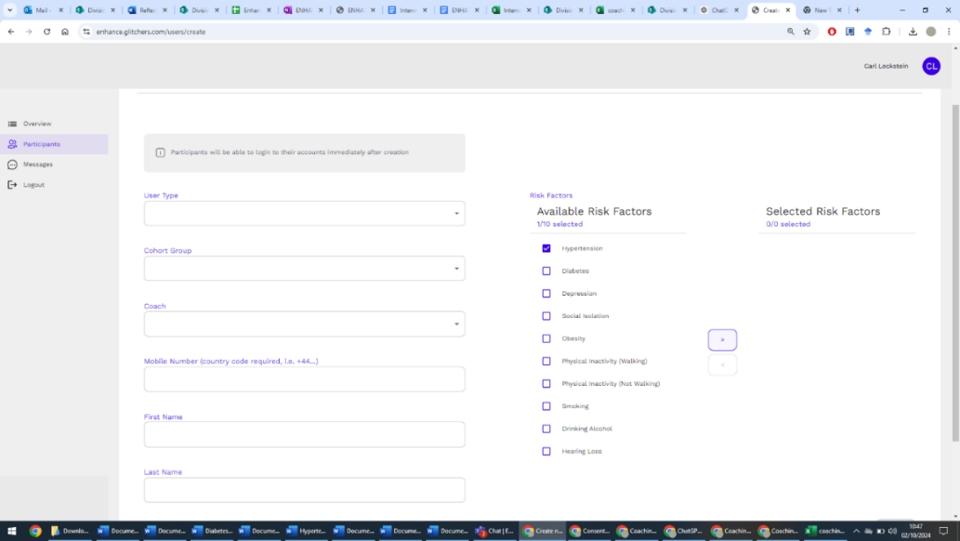

**App First Time Login Steps:**

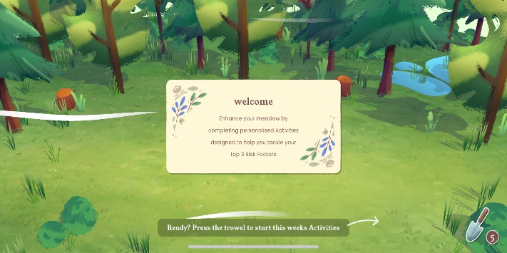

4. Login success. The Participant will be greeted with this screen and can now explore the app.

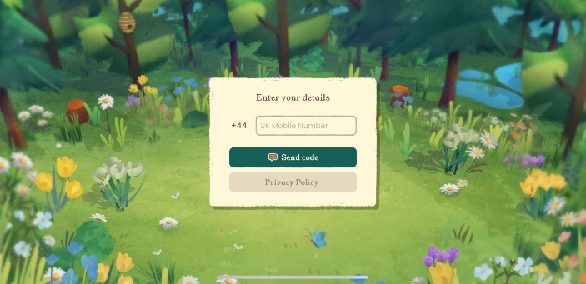

2. Enter mobile number and click send code to receive SMS login code.

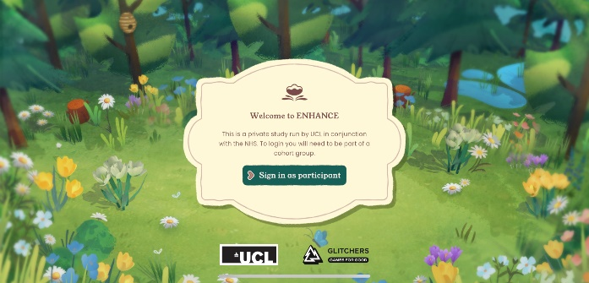

1. Click to sign in as Participant.

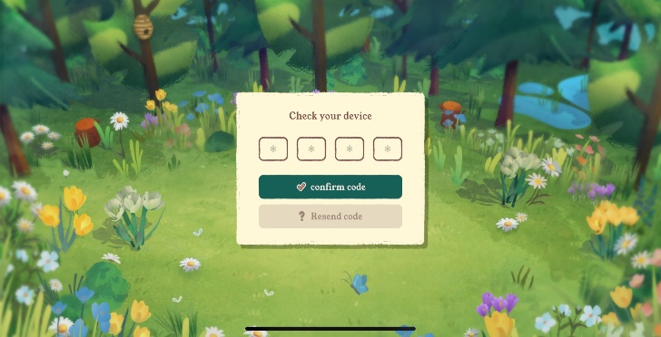

3. Wait to receive SMS login code and enter it.

## **Introduce Self-Monitoring [IF RELEVANT TO CHOSEN RISK FACTORS]**

**If Managing Blood Pressure or Getting Active haven’t been chosen by the Participant, then skip to Step 6**. If the Participant chooses these risk factors in later stages, refer to this section for guidance.

### A blue blanket with a heart on it Description automatically generatedProvision of Necessary Equipment

* **Provide the Participant with the necessary equipment** based on the first selected risk factor and demonstrate its use.
  + - * **Offer the Participant a choice:** *“Would you prefer to start with a quick demo, or would you prefer to try it yourself?”*
* **Introduce the concept of self-monitoring**, asking, *“How do you feel about tracking this yourself?” Would you like to set specific times to do it, or keep it flexible?”*

### If Managing Blood Pressure or Getting Active is Chosen First:

* Provide blood pressure monitor or pedometer ***(ONLY required for BP and PA risk factors).***
* Encourage the Participant to begin recording their blood pressure or their daily steps
  + **Example**: *“If you are ready, it could be helpful to take a few readings this week. Does that sound good to you?”*
* Ask the Participant to operate the blood pressure monitor themselves.
  + **Example**: *“I want to make sure you are able to use this monitor by yourself, so would you like to go ahead and show me how you will take your blood pressure reading?”*

## **6. Set Key Tasks (15 minutes)**

This part of the session is designed to help the Participant feel like they are already making progress within the very first session.

***Example****:* “*Now that we’ve identified the risk factors to address and the app is set up, let’s set some targets for the next session. It’s important to set achievable and realistic targets that fit where you’re at now.”*

### 📱 Task 1: Encourage Participant to Explore the App Independently

* Suggest they explore the app at their own pace.
  + **Example: *“****Would you like to start by watching videos, trying out games, or perhaps just browsing around? You can choose what interests you most.”*
* **Set targets together**
  + **Example:** *“Let's set some targets together. How do you feel about aiming to explore the app this week? What do you think?”*

### **📊** Task 2: Introducing Self-Monitoring

* As explained to Participant, ask them about whether they’d like to start self-monitoring to collect some data before the next session.
  + **Example:** *“If you’re ready, we can also start including self-monitoring.”*

## **7. Closing and Next Steps (5 minutes)**

* **Encourage** the Participant to contact you if they have any questions or challenges – remind them of the **messaging feature** within the app.
* **Check-in with the Participant via the messaging feature** after the first session – some Participants may feel nervous to reach out first.
* 📅 **Schedule the second session** for the following week (subsequent sessions will be every two weeks but be flexible if the Participant requires more support).
  + **Example:** *“Let’s schedule our next session for next week. Would you prefer to stick with the same day and time, or is there another time that works better for you? After that, we’ll move to meeting every two weeks, but we can adjust that if needed.”*

**COACH ACTION: Record Information from Session in SealedEnvelope**

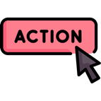During or after the session, you will need to enter **valuable data about the Coaching session with the Participant**, such as any challenges, time and date of the session.

**Log In to SealedEnvelope Here**

[**SealedEnvelope.com/access**](http://www.sealedenvelope.com/access/)

*Press CTRL + click the link with the mouse to open*

**End of Onboarding (Session 0).**

**Risk Factor-Specific Sessions**

|  |  |  |
| --- | --- | --- |
| Risk Factor Intervention | | Page |
| 1 | **❤️ Managing Blood Pressure** | 26 |
| 2 | **🍭 Managing Blood Sugar** | 32 |
| 3 | **🚬 Quitting Smoking** | 38 |
| 4 | **👂 Better Hearing** | 45 |
| 5 | **🏃 Getting Active** | 50 |
| 6 | **⚖️ Healthy Eating** | 55 |
| 7 | **🍷 Drinking Less** | 61 |
| 8 | **🧑‍🤝‍🧑 Meeting People** | 67 |
| 9 | **😞 Better Mood** | 72 |

Now you have completed the general onboarding with the Participant, the manual will now split into the risk factor-specific sections. Depending on which risk factor the Participant is currently working on, please refer to the corresponding risk factor section.



1. **Managing Blood Pressure Intervention**

At this point, the Participant has chosen Managing Blood Pressure to focus on.

# **Overview of Blood Pressure Intervention in ENHANCE**

Hypertension is high blood pressure. It usually has no symptoms and is a risk factor for dementia if left untreated. High blood pressure is generally managed with lifestyle changes, as well as medication when deemed appropriate by a patient’s doctor.

**The Primary Goal:**

* Our goal is to help the Participant go their GP practice to seek advice on how to get their high blood pressure to a healthy range.

## **The Coaching Role: Managing Blood Pressure**

## **Blood pressure readings in ENHANCE:**

📊 **Blood Pressure Monitoring**

* For the first week, you will support the Participant in completing a “**streak**” which involves measuring their own blood pressure at least **once per day for 4 days and inputting them into the app**.
* One single blood pressure reading can be high, due to things like diet, anxiety, sleep and physical activity, which **causes short-term variations**, so the average over a few days is key to produce a result that GP practices can trust as reliable.
* 📄 Once streak is complete, the ENHANCE core team will **provide you with a letter summarising their readings** for the Participant to take to their GP practice.
* 🚨 If the outcome of the streak is orange or red, then the Participant should be encouraged to share the letter with their GP practice for advice.

⚠️ **Important:**

* Your role is to **encourage the Participant to discuss high blood pressure with their GP practice,** not to diagnose or “treat” high blood pressure. If the Participant asks you any medical questions, please refer them to their GP practice.
* Week to week variations do not require immediate action or concern unless the readings are red.

## **App Content: Managing Blood Pressure (For reference)**

Each week, the Participant will be encouraged to record their blood pressure in the app, play some of the games, and watch two videos every fortnight.

|  |  |
| --- | --- |
| Week 1  Managing Blood Pressure: Getting Started | * Description of blood pressure * Introduction to systolic and diastolic numbers * Traffic light system explanation (green, orange, red) * Advice from Dr. Sharma (video) * How to measure blood pressure (video) * Top tips for measuring blood pressure. * Informing Participants that high blood pressure can be managed through lifestyle changes. |
| Week 2  Speaking to your GP Practice & Benefits of Managing Blood Pressure | * **Risk factors** for high blood pressure. * Reminder to record blood pressure reading in the app. * Other **places a BP test can be done**. * NHS advice (video) * How your GP practice can help * Personal story – Clive (video) * **Deciding on treatment** * **Benefits of managing** blood pressure – brain health, heart health, kidney health * Effects on mental health |
| Week 3  Managing Blood Pressure: Exercise | * Benefits of **exercising** and recommended amount * Simple ways to incorporate exercise. * **Recommendations** of types of exercises – those good for BP and those bad for BP * **Tips** for getting active |
| Week 4  Managing Blood Pressure: Diet | * **Benefits** of healthy eating * **General diet tips** to manage blood pressure. * Tips for **reducing salt.** * **Benefits** of reducing salt * General healthy eating tips |
| Week 5  Managing Blood Pressure:  Smoking & Alcohol | * How **smoking** affects blood pressure * **Benefits** of **becoming a non-smoker** * **Tips** to become smoke-free. * How **alcohol** affects blood pressure * Immediate & long-term **benefits of cutting down alcohol**. * **Tips** for drinking less |
| Week 6  Summary | * Personal story (Jeff) * Summary of the key points from each week & moving forward. |

The content overview below shows what each video of the 6-week BP risk factor includes.

# **Managing Blood Pressure: Session 1 (30-60 minutes)**

**🧠 Meeting Preparation:** Read the **Participant activity report that the ENHANCE core team will send you.** In many cases the Participants will not have recorded readings, that’s OK.

## **Check-In & Review (10-15 minutes)**

**Participant has been asked in App:** *“Please record your blood pressure using the device provided.”*

* + ✔️ **Participant has completed the 4-day streak:** The ENHANCE core team will give the Coach a letter for the Participant to take to their GP practice, summarising their results.
  + ❌ **Participant hasn’t recorded their blood pressure or used the app:** Offer support and troubleshoot any issues

## **Discussion on Managing Blood Pressure (20 minutes)**

💬 Open Conversation about Understanding of Blood Pressure:

* + Discuss Week 1 video (watch it with them if they haven’t). Encourage the Participant to reflect on what they’ve learned so far. Give them space to share thoughts, insights, or concerns.

📌 Key Points to Address

*Even if the Participant doesn’t bring it up, make sure to cover these* ***critical points****:*

* **Lack of Symptoms:** *“You can’t feel when your blood pressure is high – most people have no symptoms”*
* **Ongoing Management:** *“Even if your blood pressure is fine one day, it doesn’t mean it’s cured. You still need to continue taking any prescribed medication.”*
* **Medication Consistency (if relevant):** *“If you’re taking blood pressure tablets, it’s important to take them every day.”*

🛑 Assess Motivation and Barriers

* **Explore any emotional or practical challenges** that may have surfaced.

***Set 1-3 Goals - Managing Blood Pressure (15-20 minutes)**

🎯 *Encourage the Participant to take the lead, ask them to set up to three goals to work on over the next few weeks for managing their blood pressure.*

* Ensure the goals are **SMART** and personalised to the Participant’s readiness and motivation.
  + *“It’s important these goals fit into your daily life and feel achievable. We can adjust them if needed.”*

💡 Example of **SMART** Goals: Offer some suggestions, but ensure the Participant has the final say:

|  |  |  |  |  |  |
| --- | --- | --- | --- | --- | --- |
| **Goal** | **Specific** | **Measurable** | **Achievable** | **Relevant** | **Time-Bound** |
| **Diet** | Eat five servings of fruits/vegetables daily. | Track servings in a food log. | Plan meals/snacks weekly. | Helps with BP management. | For 8 weeks, then reassess. |
| **GP practice appointment** | Scheduling appointment with GP practice | Confirm appointment date within the next 3 days | Contact GP practice by phone or online to book appointment. | Regular check-ups with GP practice are important if my blood pressure is high | Appointment scheduled and confirmed within 1 week |

*“These are just ideas—what do you think? Are there any other goals you’d like to set?”*

**Checking Goal Confidence (Achievable)**: IF the Participant is struggling with motivation, ask:

"On a scale of 1-10, how confident do you feel about achieving this in the next two weeks?"

1 = Not at all confident

10 = Extremely confident

🌟 Aim for 7-8: Challenging but achievable!

## **Closing and Next Steps (5 minutes)**

🔑 Briefly recap the key points and schedule the next session for two weeks’ time. ***Be flexible if two weeks does not work and Participant needs weekly support.*** Remind them they can reach out via the app if needed.

**COACH ACTION: Record Information from Session in SealedEnvelope**

**Log In to SealedEnvelope Here**

[**SealedEnvelope.com/access**](http://www.sealedenvelope.com/access/)

*Press CTRL + click the link with the mouse to open*

**End of Managing Blood Pressure Session 1.**

# **Managing Blood Pressure: Session 2-3 (~30 minutes)**

## **Review the Participant’s Progress**

* ****🎯 **Goal Review:** Reflect on the goals from Session 1, highlighting successes, discuss obstacles, and adjust goals if needed.
* 📱 **App Usage:** Review app engagement, including watching videos.
  + **Praise** any engagement and offer help if they faced challenges using the app.

## **Problem-Solving:**

* 💡 **Address Issues:** Ask about any challenges and offer solutions.
  + **Example actions**: Demonstrate the blood pressure monitor again, assist with app navigation.
  + ***Reassurance:*** *Emphasise that challenges are part of the process and can be managed.*

## **3. Next Steps:**

* 💪 **Remind Participants:** They will measure and record their blood pressure for a final time. **Note: participants can complete a 4-day streak in the first week of the intervention. Once completed, they can record their BP once per week thereafter.**
* ⚡**Highlight Impact:** Emphasise long-term benefits of diet and lifestyle change on BP.
* ⏩ After Session 3: **Prepare for transition** to the next risk factor.
* 🎉 **Positive Reinforcement:**
  + **Celebrate achievements,** even if small, and highlight how these changes impact blood pressure
* 💡 **Continued Monitoring:** Emphasise that the Participant can still **monitor their blood pressure** as they move on to the next area of focus.

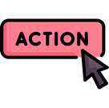**COACH ACTION: Record Information from Session in SealedEnvelope**

**Log In to SealedEnvelope Here**

[**SealedEnvelope.com/access**](http://www.sealedenvelope.com/access/)

*Press CTRL + click the link with the mouse to open*

Additional Notes for Coaches:

* **Emphasise long-term effort:** Reinforce that managing blood pressure is an ongoing process.
* **Flexibility in progress:** Acknowledge that everyone moves at their own pace. The Participant should feel comfortable with where they are in their journey.



1. **Managing Blood Sugar Intervention**

At this point, the Participant has chosen Managing Blood Sugar as the risk factor to focus on.

# **Overview: Managing Blood Sugar Intervention**

**HbA1c Testing and Results:** The HbA1c test measures average blood sugar levels over three months, with high levels indicating possible diabetes which can lead to serious complications.

* **Baseline Assessment:** A research nurse conducts a HbA1c test via finger prick/venous method
* **Onboarding (Session 0):** 
  + **< 42 mmol/mol (Normal):** No intervention
  + **42-47 mmol/mol (Pre-diabetes):** Will have been given a letter to inform their GP practice.
  + **≥ 48 mmol/mol (Diabetes):** This is the range where people are getting the intervention. If they decline, they still receive a letter for their GP practice.

**The Primary Goal:**

* The intervention’s main goal is to encourage the Participant to contact their GP practice about their HbA1c results and act on the advice given. Coaches support the Participant in engaging with their healthcare providers and the app provides educational videos on lifestyle changes.

## **Coaching Role: Helping Engagement with GP Practice**

📊 **HbA1c Monitoring and GP practice contact:**

* Encourage the Participant to visit their GP practice about their high HbA1c levels.
* ****The core team will have given you a letter summarising their results for the GP practice 📝.
* Offer support through weekly/bi-weekly check-ins to ensure they engage with their GP practice visits 🕑.

**Monitor App Engagement**

* Ensure the Participant watches the videos and completes the weekly check-in questions.

**Encourage Positive Health Behaviour:**

* Help the Participant to set realistic goals for diet, exercise, and follow any medical advice, such as taking medication or attending a lifestyle programme.
* Address barriers if they aren’t engaging or progressing on their goals.

⚠️ If the Participant asks you any medical questions, for example about treatment, please refer them to their GP practice.

## **App Content: Managing Blood Sugar (for reference)**

Each week, the Participant will be encouraged to talk to someone at their GP practice about their blood sugar letter, play some of the games, and watch two videos every fortnight.

|  |  |
| --- | --- |
| Managing Blood Sugar: Getting Started | * A device with a blood drop on it    Description automatically generatedExplanation of blood sugar and the HbA1c test * HbA1c letter for GP practice * Symptoms of high blood sugar/type 2 diabetes * Managing blood sugar levels overview – lifestyle changes * Long-term complications * Benefits of managing blood sugar levels |
| Managing Blood Sugar: Speaking to your GP Practice & Benefits | * How type 2 diabetes is **diagnosed** * Personal story of getting a diagnosis * Introducing **diabetes care teams**, who they are and what they can do * Introducing **diabetes care pans** * **Questions** to ask your diabetes care team * What happens **after being diagnosed** * **Help & support** available |
| Managing Blood Sugar: Diet | * Introducing managing and reversing high blood sugar levels through diet * Which **food groups to eat and which to cut down** * Tips for **reducing sugar** * Personal stories – reducing sugar and changing diet |
| Managing Blood Sugar: Exercise | * Introducing managing and reversing high blood sugar levels through **exercise** * Four personal stories regarding exercise to manage blood sugar levels. |
| Managing Blood Sugar: Mental Health | * Mental challenges of managing blood sugar levels * Diabetes distress – the symptoms * **Low mood & anxiety** * Things that help * **Self-care tips** * Deep breathing exercise |
| Managing Blood Sugar: Summary & Next Steps | * Summary of the key points from each week & moving forward. |

Below is an overview of the content the Participant will see within each managing blood sugar video.

# **Managing Blood Sugar: Session 1 (30-60 minutes)**

**🧠 Meeting Preparation:** Read the **Participant activity report that the ENHANCE core team will send you.** In many cases the Participants will not have recorded readings, that’s OK.

## **Check-In & Review (10-15 minutes)**

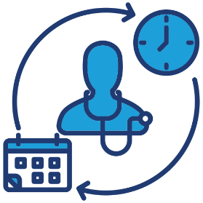**Participant has been asked in app***: “Have you spoken to anyone in your GP practice team about your high blood sugar letter?”*

* ✔️ **Participant has shared their HbA1c result:** Discuss how it went with their GP practice and any advice or actions taken and see if they can integrate into the goals for the next meeting
* ❌ **Participant hasn’t shared their result yet:** Encourage them to do so and troubleshoot.

## **Discussion on Managing Blood Sugar (20 minutes)**

💬 Open Conversation about Understanding of Managing Blood Sugar:

* + **Discuss Week 1 video (watch it with them if they haven’t). Encourage the Participant to reflect on what they’ve learned so far. Give them space to share thoughts, insights, or concerns.

📌 Key Points to Address

*Even if the Participant doesn’t bring it up, make sure to cover these* ***critical points****:*

* **Lack of Symptoms:** *“Some people can feel when their blood sugar is high – do you notice? What do you feel? Some don’t. It’s important to monitor and make sure you are managing it daily.”*
* **Ongoing Management:** *“Managing blood sugar is an ongoing process. Even if your blood sugar levels are fine one day, you still need to maintain healthy habits.”*
* **Importance of Contacting GP Practice:** *“If your HbA1c is high, working with your GP practice on a diabetes care plan is key to avoiding serious health complications.”*

🛑 Assess Motivation and Barriers

* **Explore and tackle any emotional or practical challenges** that may have surfaced.

📈 Assess Readiness for Change

* + - **Example:** *“What do you think is the next step for you?”*

## **Set 1-3 Goals - Managing Blood Sugar (15-20 minutes)**

🎯 *Encourage the Participant to take the lead, ask them to set up to three goals to work on over the next few weeks for managing their blood pressure.*

* Ensure the goals are **SMART** and personalised to the Participant’s readiness and motivation.
  + *“It’s important these goals fit into your daily life and feel achievable. We can adjust them if needed.”*

💡 **SMART** Goals: Offer some suggestions, but ensure the Participant has the final say:

|  |  |  |  |  |  |
| --- | --- | --- | --- | --- | --- |
| **Goal Type** | **Specific** | **Measurable** | **Achievable** | **Relevant** | **Time-bound** |
| **HbA1c Management** | Share HbA1c results with GP practice. | Confirm appointment with GP practice. | Use check in-questions for follow-ups. | Helps with blood sugar management. | Within 2 weeks. |
| **Healthy Eating** | Eat five servings of fruits/vegetables daily. | Track servings in a food log. | Plan meals | Helps with blood sugar management. | Over the next month |
| **Physical Activity** | Walk 30 minutes a day, 3-5 days a week. | Track walks in the app. | Set daily reminders. | Physical activity can help control blood sugar. | For the next 8 weeks, then reassess. |

*“These are just ideas—what do you think? Are there any other goals you’d like to set?”*

**Checking Goal Confidence (Achievable)**: IF the Participant is struggling with motivation, ask:

"On a scale of 1-10, how confident do you feel about achieving this in the next two weeks?"

1 = Not at all confident

10 = Extremely confident

## **Closing and Next Steps (5 minutes)**

🔑 Recap key points and schedule the next session for two weeks’ time. ***Be flexible if they need weekly support.*** Remind them they can reach out via the app if needed.

**COACH ACTION: Record Information from Session in SealedEnvelope**

****During or after the session, you will need to enter **valuable data about the Coaching session with the Participant**, such as goals, any challenges, time and date of the session, etc.

**Log In to SealedEnvelope Here**

[**SealedEnvelope.com/access**](http://www.sealedenvelope.com/access/)

*Press CTRL + click the link with the mouse to open*

**End of Managing Blood Sugar Session 1.**

# **Managing Blood Sugar Session 2 & 3 - Progress Check**

## **Review the Participant’s Progress**

* 🎯 **Goal Review:** Reflect on the goals from Session 1, highlighting successes, discuss obstacles, and adjust goals if needed.
* 📱 **App Usage:** Review app engagement, including watching videos.
  + **Praise** any engagement and offer help if they face challenges using the app or going to their GP practice with their blood sugar letter.

## **Problem-Solving:**

* 💡 **Address Issues:** Ask about any challenges and offer solutions.
  + **Example actions**: Support them in going to their GP practice with their blood sugar letter, assist with app navigation.
  + **Reassurance*:*** *Emphasise that challenges are part of the process and can be managed.*

## **3. Next Steps:**

* ⚡**Highlight Impact:** Emphasise the long-term benefits of diet and lifestyle changes on blood sugar.
* ⏩ After Session 3: **Prepare for transition** to the next risk factor.
* 🎉 **Positive Reinforcement:**
  + **Celebrate achievements,** even if small, and highlight how these changes impact blood sugar levels.
* 💡 **Continued Monitoring:** Emphasise that the Participant can still **maintain blood sugar goals** as they move on to the next area of focus.

**COACH ACTION: Record Information from Session in SealedEnvelope**

**Log In to SealedEnvelope Here**

[**SealedEnvelope.com/access**](http://www.sealedenvelope.com/access/)

*Press CTRL + click the link with the mouse to open*

Additional Notes for Coaches:

* 🏃‍♂️ **Emphasise long-term effort:** Reinforce that managing blood sugar is an ongoing process.
* 🔄 **Flexibility in progress:** Acknowledge that everyone moves at their own pace. The Participant should feel comfortable with where they are in their journey.



1. **Quitting Smoking Intervention**

At this point, the Participant has chosen Quitting Smoking to focus on.

# **Overview of the Quitting Smoking Intervention in ENHANCE**

Smoking increases the risk of heart attack, stroke, dementia and other health issues. Quitting smoking is one of the most impactful and positive lifestyle changes individuals can make to enhance their brain health and overall well-being.

**The Primary Goal:**

* + Assist the Participant in setting a quit date and developing a personalised quit plan. This includes goal setting, identifying triggers, and creating strategies to cope with cravings.

## **Quitting Smoking Plan in ENHANCE**

* **Baseline Assessment (Pre-Onboarding):** Nurse confirms Participant is a current smoker.
* **Onboarding Session (Session 0):** The Coach discusses the option of targeting smoking as a risk factor.
  + - **If interested:** Participant is introduced to the Quitting Smoking intervention. The Coach helps them choose a quit date and develop a quit plan.
    - **If not ready to quit**: The Participant can choose another risk factor, and the Quitting Smoking intervention is not offered.

## **The Coaching Role: Supporting Participants**

📝 **Setting Up the Quit Plan:**

📅 **Quit Date:** In the first week, support the Participant in selecting their quit date on the app’s calendar.

* **Quit Plan Development:** Assist the Participant in completing their quit plan, which includes identifying reasons to quit and recognising triggers.

⚠️ **Monitoring**

* **Check-ins:** Regularly follow up on their quit date and progress with the plan.
* **Problem-Solving:** If challenges arise, help the Participant adjust their plan to overcome obstacles.

🚨 **Quit Date Alerts**

* Use the app to send reminders via the app/SMS/email as the quit date approaches, encouraging the Participant to review their quit plan and reinforce their commitment.

⚠️**Your role is to** provide support and guidance. **Reassure** the Participant that quitting smoking is challenging and that setbacks are common. **Encourage** them to view their journey as a process and celebrate small victories along the way.

* If the Participant asks you questions about medical symptoms (e.g. breathing problems related to smoking) please ask them to speak to their GP practice.

## **App Content: Quitting Smoking (for reference)**

Each week, the Participant will be encouraged to reflect on their quit date in the app, play some of the games, and watch two videos every fortnight.

|  |  |
| --- | --- |
| Quitting Smoking: Getting Started | * A box of cigarettes with a black background    AI-generated content may be incorrect.Explanation of the health benefits of quitting smoking * Personal reasons to quit smoking * Overview of cravings * Services for support and smoking alternatives * Introducing the quit plan * Personal story of quitting smoking |
| Quitting Smoking: Your Triggers | * **A brain with a hand pointing at it    AI-generated content may be incorrect.**Overview of smoking **triggers** * Explanation of **personal triggers** * **Breaking the connection between triggers and smoking** * Nicotine cravings * **Understanding emotional triggers** * **The impact of social events** on smoking |
| Quitting Smoking: Your Reasons to Stop | * **A red and white stop sign    AI-generated content may be incorrect.Reasons to go smoke-free** * **Improvement in physical and mental health** * **Benefits** for family members * How **quitting saves money** * Encourages **listing personal motivations to quit** |
| Quitting Smoking: Benefits Of Stopping | * A hand holding a sign    AI-generated content may be incorrect.The **immediate** **benefits** of quitting * **Long term benefits** of quitting * **Brain, heart, and lung benefits** of quitting * **Improvements** to **mental health** * Better Health video |
| Quitting Smoking: Becoming Smoke-Free | * **A no smoking sign with smoke    AI-generated content may be incorrect.**Description of **stop smoking aids** * **Techniques** to **fight cravings** * **Importance** of **family motivation** * Details of **stopping smoking services** available * Better Health video |
| Quitting Smoking: Kath's Story | * A paper with different colored squares    AI-generated content may be incorrect.Personal story about quitting smoking |

# **Quitting Smoking: Session 1 (30-60 minutes)**

🧠 **Meeting Preparation**: Read the **Participant activity report that the ENHANCE core team will send you**. In many cases the they will not have completed the check-in questions, that’s OK.

## **1. Check-In & Review (10-15 minutes)**

**Participant is first asked in the app:** *“Are you ready to set a quit date?”*

If the Participant selects **yes**, then the app asks: *“Please select a date” à “How many cigarettes did you smoke in the last week?” à “Why are you quitting?” à “What makes you smoke?”*

Then from their second week onwards, they will only be asked *“How many cigarettes did you smoke in the last week?”*

* ✔️ **Participant is ready to set a quit date and has shared their triggers and motivations to quit:** Discuss this with them to create a tailored quit plan.
* ❌ **Participant is not ready to set a quit date:** Problem-solve, inform them that this is an important aspect of the Quitting Smoking intervention and see if they would like to try to set one or move to a different risk factor.

## **Setting a Quit Date & Developing the Quit Plan (20 minutes)**

📅 Setting up the Quit Date:

* Help the Participant choose a quit date, aiming for a realistic and achievable timeline that they feel comfortable with. Quit dates can be anytime during the 6-week risk factor module. **You can send this completed plan via the app/SMS.**

🚬 Develop a Quit Plan:

* **💪** Reasons/Motivations for Quitting: Using the Participant’s app answers, engage in a discussion about the reasons they want to quit. Encourage them to reflect on motivations.
  + **🔥** Identifying Triggers: Using the Participant’s app answers, guide them in recognising the key moments or situations that trigger their smoking.
* **👨‍👩‍👧‍👦** Identifying Sources of Support and Coping Strategies: Encourage the Participant to access NHS resources to support them quitting smoking, including clinics and nicotine replacement.
  + Tell the Participant they can Google *‘NHS Stop Smoking Service’* for a list of resources.

🛑 Assess Motivation and Barriers

* **Explore and tackle any emotional or practical challenges** that may have surfaced.

📈 Assess Readiness for Change

* + - **Example:** *“What do you think is the next step for you in quitting smoking?”*

📌 Key Points to Address

*Even if the Participant doesn’t bring it up, make sure to cover these* ***critical points****:*

* **Long-Term Benefits:** “*Quitting smoking is one of the most positive changes you can make for your long-term brain health and overall well-being.*”
* **Health Risks:** *“Smoking harms your brain and increases the risk of dementia. Every cigarette avoided is a step towards protecting your health.”*
* **There is a lot of help available.** *“You are not alone”.*

## **Set 1-3 Goals – Quitting Smoking (15-20 minutes)**

🎯 *Encourage the Participant to take the lead, ask them to set up to three goals to work on over the next few weeks for quitting smoking.*

* Ensure the goals are **SMART** and personalised to the Participant’s readiness and motivation.

💡 Example of **SMART** Goals: Offer some suggestions, but ensure the Participant has the final say:

|  |  |  |  |  |  |
| --- | --- | --- | --- | --- | --- |
| **Goal Type** | **Specific** | **Measurable** | **Achievable** | **Relevant** | **Time-bound** |
| **Quit Plan** | Develop a plan with strategies to manage cravings | Track progress on the app | Practice 1 strategy daily | Essential for staying on track | Over the next 4 weeks |
| **Triggers** | Identify five smoking triggers | Log them in the app | Review them in each Coaching session | Helps reduce smoking habits | Over the next 4 weeks |

*“These are just ideas—what do you think? Are there any other goals you’d like to set?”*

**Checking Goal Confidence (Achievable)**: IF the Participant is struggling with motivation, ask:

"On a scale of 1-10, how confident do you feel about achieving this in the next two weeks?"

1 = Not at all confident

10 = Extremely confident

## **Closing and Next Steps (5 minutes)**

🔑 Briefly recap the key points and schedule the next session for two weeks’ time. ***Be flexible if two weeks does not work.*** Remind them they can reach out via the app if needed.

**COACH ACTION: Record Information from Session in SealedEnvelope**

**Login to SealedEnvelope Here**

[**SealedEnvelope.com/access**](http://www.sealedenvelope.com/access/)

*Press CTRL + click the link with the mouse to open*

**End of Quitting Smoking Session 1.**

# **Quitting Smoking Session 2 & 3 – Progress Check**

## **Review the Participant’s Progress**

* 🎯 **Goal Review:** Reflect on the goals from Session 1, highlighting successes, discuss obstacles, and adjust goals if needed. Review their quit plan regularly and update it if needed.
  + Note any patterns, such as avoiding triggers or managing cravings, and explore what helped them stay on track.
* 📱 **App Usage:** Review app engagement, including watching videos.
  + **Praise** any engagement and offer help if they face challenges using the app or their plan.

## **Problem-Solving:**

* 💡 **Address Issues:** Ask about any challenges and offer solutions.
  + **Example actions**: Support them in adjusting their quit plan
  + ***Reassurance:*** *Emphasise that challenges are part of the process and can be managed.*

## **3. Next Steps:**

* ⚡**Highlight Impact:** Emphasise the long-term benefits of strategies to reduce/quit smoking.
* ⏩ After Session 3: **Prepare for transition** to the next risk factor.
* 🎉 **Positive Reinforcement:**
  + **Celebrate achievements,** even if small, such as remaining smoke-free or reducing smoking frequency and discuss any barriers to unmet goals.
* 💡 **Continued Monitoring:** Emphasise that the Participant can still **follow their quit plan** as they move on to the next area of focus.

**COACH ACTION: Record Information from Session in SealedEnvelope**

**Login to SealedEnvelope Here**

[**SealedEnvelope.com/access**](http://www.sealedenvelope.com/access/)

*Press CTRL + click the link with the mouse to open*

**End of Quitting Smoking Intervention.**



**4. Better Hearing Intervention**

At this point, the Participant has chosen Better Hearing as the risk factor to focus on.

# **Overview of the Better Hearing Intervention**

**The Primary Goal:** to help the Participant either:

* Access help with their **hearing loss through their GP practice,** with the HearWHO test results.
* Encourage them to **use hearing aids regularly** (if they already have them but use < 1 hour/day).
* Show them that better hearing can **improve quality of life and cognition**.

This will be achieved through **weekly videos in the app**, which provide knowledge about hearing health.

**The Coaching Role: Better Hearing**

* From Week 1, you will encourage the Participant to discuss their **hearing with their GP practice for a referral for audiological assessments and hearing aids (if appropriate).** The core team will give you a letter for them with their hearing test results.
* **The Participant will have nominated a family members or friend to be involved.**

⚠️If the Participant asks medical questions, you should ask them to talk to their GP practice.

## **App Content: Better Hearing (for reference)**

|  |  |
| --- | --- |
| Better Hearing: Getting Started | * Introduces hearing loss, its causes, and its impact on daily life. * Emphasises the importance of addressing hearing loss and seeking help. |
| Better Hearing: How Hearing Aids Can Help? | * Discusses how **hearing aids improve hearing, brain health, and overall quality of life.** * Personal story (George) - Shares a testimonial from someone who benefited from using hearing aids. |
| Better Hearing: Getting Your Hearing Checked | * Describes the **process** of **getting a hearing test** and what to expect at a **GP or audiology appointment**. * Explains the **steps involved in obtaining hearing aids**. |
| Hearing Aids: Tips to Use Them | * Provides **practical advice for integrating hearing aids** into daily life and troubleshooting common issues. * **Encourages** **persistence** and seeking help if problems arise. |
| Hearing Aids: Overcoming Challenges | * **Addresses difficulties** that new users may experience, such as adjusting to new sounds and fitting hearing aids. * **Offers solutions** for these challenges and emphasises the importance of follow-up support. |
| Better Hearing, Better Life | * Focuses on **how hearing aids can improve social life, hobbies, and overall independence.** * Highlights the **positive impact on mental and physical well-being.** |

Each week, the Participant will be encouraged to go their GP practice about their hearing and to use their hearing aids.

# **Better Hearing: Session 1 (30-60 minutes)**

🧠 **Meeting Preparation**: Read the **Participant activity report that the ENHANCE core team will send you**. In many cases the Participants will not have completed the check-in questions, that’s OK.

**1. Check-In & Review (up to 20 minutes)**

**Participant is first asked in the app:** *“Have you spoken to your GP practice about your hearing?” à “Have you seen an audiologist to test your hearing?” à “Have you got hearing aids to wear?”*

* ✔️ **If the Participant has made an appointment with their GP practice or seen their GP, discuss what will come next with them:**
  + **During the GP appointment**: They will likely refer them to an audiologist for a hearing test.
  + **Seeing an audiologist**: They will do hearing tests and discuss if hearing aids would help.
  + **Getting and using hearing aids:** Initial adjustment may be challenging; encourage daily use and tell them that they can return if they have problems; See Week 4 & 5 videos for hearing aid tips (Coach reference)
* ❌ **If the Participant hasn’t made an appointment with their GP practice or played any games/watched any videos: Offer support and troubleshoot** any issues.

## **Discussion on Better Hearing (20 minutes)**

🧠 Open Conversation about Understanding of Hearing Health:

* + Discuss Week 1 video (watch it with them if they haven’t). Encourage the Participant to reflect on what they’ve learnt so far. Give them space to share thoughts, insights, or concerns.

📌 Key Points to Address

*Even if the Participant doesn’t bring it up, make sure to cover these* ***critical points****:*

* **Lack of symptoms:** *“Hearing loss often happens gradually, and many people don’t notice how much they’re missing. It’s important to get checked even if you think your hearing is fine.”*
* **Hearing aids consistency (if relevant):** *“Wearing hearing aids daily, even in quiet settings, helps your brain adjust and improves your ability to hear in more challenging environments like conversations or noisy places.”*
* **Long-term effect (if relevant):** *“Even if you can manage without hearing aids sometimes, hearing loss can still impact your brain health and quality of life over time.”*

## **Set 1-3 Goals – Better Hearing (15-20 minutes)**

🎯 *Encourage the Participant to take the lead, ask them to set up to three goals to work on over the next few weeks for improving their hearing.*

* Ensure the goals are **SMART** and personalised to the Participant’s readiness and motivation.
  + *“It’s important these goals fit into your daily life and feel achievable. We can adjust them if needed.”*

💡 Example of **SMART** Goals: Offer suggestions, but ensure the Participant has the final say:

|  |  |  |  |  |  |
| --- | --- | --- | --- | --- | --- |
| **Goal Type** | **Specific** | **Measurable** | **Achievable** | **Relevant** | **Time-bound** |
| **GP practice** (if they have not had hearing aids) | Scheduling appointment with GP practice | Has the appointment been made? | Contact GP practice by phone or online to book appointment | A referral to an Audiologist might be made to get hearing tests and hearing aids | Appointment scheduled and confirmed within 1 week |
| **Use of hearing aids** (if they have hearing aids) | How long do they wear a day | Number of hours | Set up a routine to wear them every day | They may be able to enjoy music and TV without the volume at full blast | Routine set up and begin wearing them within 1 week |

*“These are just ideas—what do you think? Are there any other goals you’d like to set?”*

**Checking Goal Confidence (Achievable)**: IF the Participant is struggling with motivation, ask them –

"On a scale of 1-10, how confident do you feel about achieving this in the next two weeks?"

1 = Not at all confident

10 = Extremely confident

🌟 Aim for 7-8: Challenging but achievable!

## **Closing and Next Steps (5 minutes)**

🔑 Briefly recap the key points and schedule the next session for two weeks’ time. ***Be flexible if two weeks does not work and the Participant needs weekly support.*** Remind them they can reach out via the app if needed.

**COACH ACTION: Record Information from Session in SealedEnvelope**

****During or after the session, you will need to enter **valuable data about the Coaching session with the Participant**, such as goals, any challenges, time and date of the session, etc.

**Log In to SealedEnvelope Here**

[**SealedEnvelope.com/access**](http://www.sealedenvelope.com/access/)

*Press CTRL + click the link with the mouse to open*

**End of Better Hearing Session 1.**

# **Better Hearing: Session 2 & 3 - Progress Check**

## **Review the Participant’s Progress**

* 🎯 **Goal Review:** Reflect on the goals from Session 1, highlighting successes, discuss obstacles, and adjust goals if needed.
* 📱 **App Usage:** Review app engagement, including watching videos.
  + **Praise** any engagement and offer help if they face challenges using the app or going to their GP practice or in using their hearing aids.

## **Problem-Solving:**

* 💡 **Address Issues:** Ask about any challenges and offer solutions.
  + **Example actions**: Support them in going to their GP practice about their hearing.
  + **Reassurance*:*** *Emphasise that challenges are part of the process and can be managed.*

## **3. Next Steps:**

* ⚡**Highlight Impact:** Emphasise the long-term benefits of getting their hearing checked and using hearing aids.
* ⏩ After Session 3: **Prepare for transition** to the next risk factor.
* 🎉 **Positive Reinforcement:**
  + **Celebrate achievements,** even if small, and highlight how these changes can improve their hearing, cognition and quality of life.
* 💡 **Continued Monitoring:** Emphasise that the Participant can still **maintain goals around using their hearing aids** whilst they move to the next area of focus.

**COACH ACTION: Record Information from Session in SealedEnvelope**

**Log In to SealedEnvelope Here**

[**SealedEnvelope.com/access**](http://www.sealedenvelope.com/access/)

*Press CTRL + click the link with the mouse to open*

**End of Better Hearing Intervention.**

Additional Notes for Coaches:

* 🏃‍♂️ **Emphasise long-term effort:** Reinforce that managing their hearing is an ongoing process.
* 🔄 **Flexibility in progress:** Acknowledge that everyone moves at their own pace. The Participant should feel comfortable with where they are in their journey.

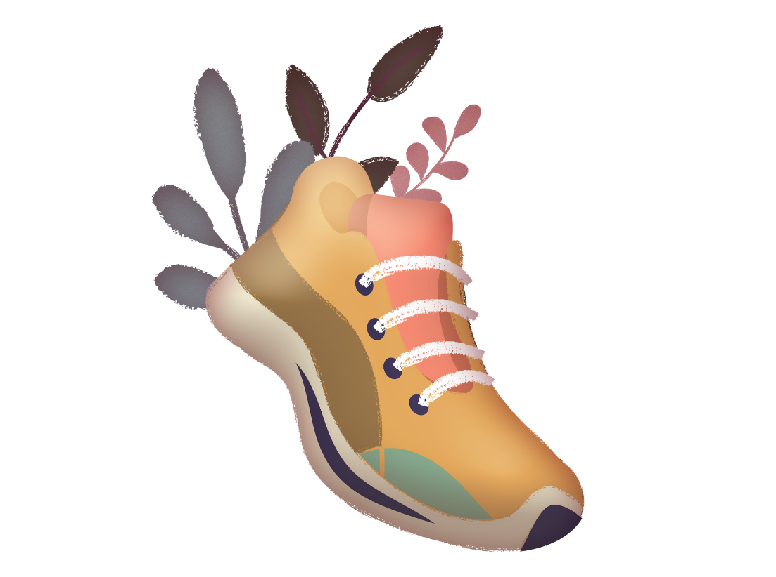

1. **Getting Active Intervention**

At this point, the Participant has chosen Getting Active as the risk factor to focus on.

# **Overview of Getting Active Intervention in ENHANCE**

**The Primary Goal:**

* To **help the Participant increase their physical activity to 2.5 hours per week.**
* This is through **educational videos, and Coach guidance, and support**.
* To **improve strength, balance, and fitness levels**.
* The Participant will choose the activity, and if they want to walk, you will discuss how they will measure this.

## **Teacher with solid fillA person and person sitting at a table with a computer Description automatically generatedThe Coaching Role: Getting Active**

Focus on the Participant’s chosen realistic, incremental changes in physical activity.

 Assist in setting specific, measurable, achievable, relevant, and time-based (**SMART**) goals.

 Celebrate successes and progress, no matter how small.

 Check that the Participant can use a pedometer.

 Provide help to use the ENHANCE app if required.

## **App Content: Getting Active (for reference)**

|  |  |
| --- | --- |
| **Getting Started** | * **Introduction** to the ‘Getting Active’ module * The **benefits** of physical activity * **Exercise** **recommendations** * Information on **goal setting and progress monitoring** * **All-in-one workout video** (25 minutes) |
| **Brain Health** | * **Margaret’s Story** * **Goal Setting** * Workout video: **Aerobic – Strength - Balance** (20 minutes) |
| **Exercise for Your Heart** | * **Benefits** of aerobic exercise & **Exercise recommendations** * **Aerobic exercise examples** * **Dance aerobic video** (20 minutes) |
| **Exercise for Your Strength** | * **Benefits** of **strength training & Examples** of **strength exercises** * **Videos: 1) Strength exercise** (20 minutes) 2**) Fat burner** (5 minutes) |
| **Getting Active – Balance Exercise** | * Introduction to **balance** **exercise & Benefits** of improving balance * **Examples** of balance exercises * **Videos: 1) Balance exercise** (10 minutes) & **2): HIIT workout** (5 minutes) |
| **Staying Active** | * **Video 1: Boxing-inspire aerobic workout** (15 minutes) * **Video 2: Chaired Yoga workout** (14 minutes) * Reminder to continue adding exercises to daily routine |

# **Getting Active: Session 1 (30-60 minutes)**

**🧠 Meeting Preparation:** Read the **Participant activity report that the ENHANCE core team will send you.** Some Participants might not have answered check-in questions, that’s OK.

Remember the Participant *should* have chosen their activities in the app, but if they haven’t you will need to do this in the first session.

## **Check-In & Review (10-15 minutes)**

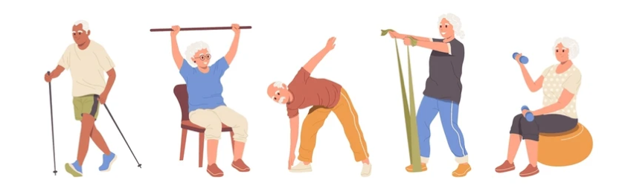**Participant has been asked in App:**

1. “Choose activities for next week”.
2. “Which days next week will you do the activities?”

* ✔️ **If the Participant has completed the check-in:** Acknowledge the Participant’s commitment and progress (e.g., app activity, or any other efforts). If they miss a planned day, reassure them that this is normal and to keep going.
* ❌ I**f the Participant hasn’t completed the check-in or used the app:** Offer support and troubleshoot any issues. Assist the Participant in identifying barriers to physical activity and developing practical solutions. Encourage proactive planning and troubleshooting.

## **Discussion on Getting Active (20 minutes)**

****💬 Open Conversation about the Benefits of Physical Activity

* + Use **initiative** - be **mindful of physical activity capabilities**.
  + **Ask the Participant how they found the activities.**
  + Help problem-solve any difficulties they have had with their chosen activities.

📌 Points for Discussion

*Productively reiterate the following key points:*

* **Physical activity protects your brain:** “*Doing 2 ½ hours or more of physical activity each week can help your brain, body, and mood, and straight away makes your life better.”*
* **Encourage the Participant to discuss what activities they’d like to do.**

## **A person and person dancing Description automatically generatedSet 1-3 Goals for Getting Active (15-20 minutes)**

* Ask the Participant to choose and set their goals, explain they will be working towards them from week to week. Encourage goals that are realistic and measurable.
* Talk about ways of achieving this and discuss potential barriers and concerns.

💡 Example of **SMART** Goals:

|  |  |  |  |  |  |
| --- | --- | --- | --- | --- | --- |
| **Goal Type** | **Specific** | **Measurable** | **Achievable** | **Relevant** | **Time-bound** |
| **Increase Walking** | Walk to pick grandchild up from nursery. | Walk for 30 minutes, and specific which days and which times / count steps using pedometer. | Yes/No – have they done it.  Make sure the Participant thinks it is achievable. | Be around for family, be able to go out with friends, more energy, less stressed etc. | Over 2 weeks – 3 times a week. |
| **Increase physical activity** | Engage in physical activity based on Participant’s interests and abilities (to be agreed by Coach and Participant e.g., gardening, housework, walking ). | Track activity using pedometer, app, and/or journal. | Encourage, Coach, motivate, prompt engagement. | Improve health. | Over 2 weeks. Review progress. |

**Checking Goal Confidence (Achievable)**: IF the Participant is struggling with motivation, ask:

"On a scale of 1-10, how confident do you feel about achieving this in the next two weeks?"

1 = Not at all confident

10 = Extremely confident

🌟 Aim for 7-8: Challenging but achievable!

## **Closing and Next Steps (5 minutes)**

🔑 Briefly recap the key points and schedule the next session for two weeks’ time. ***Be flexible if two weeks does not work and Participant needs weekly support.*** Remind them they can reach out via the app if needed.

**COACH ACTION: Record Information from Session in SealedEnvelope**

****During or after the session, you will need to enter **valuable data about the Coaching session with the Participant**, such as goals, any challenges, time and date of the session, etc.

**Log In to SealedEnvelope Here**

[**SealedEnvelope.com/access**](http://www.sealedenvelope.com/access/)

*Press CTRL + click the link with the mouse to open*

**End of Getting Active Session 1.**

# **Getting Active: Session 2 & 3 – Progress Check (30 minutes)**

## **Review Progress**

* + 🎯 **Goal Review:** Reflect on the goals from Session 1, highlighting successes, discuss obstacles, and adjust goals if needed.
  + 📱 **App Usage:** Review app engagement, including watching videos.
    - **Praise** any engagement and offer help if they faced challenges using the app.

## **Problem-Solve**

* 💡 **Address Issues:** Ask about any challenges and offer solutions.
  + *What obstacles did the Participant encounte*r? Offer an appropriate solution.
* **Provide additional support**: Does the Participant require more interaction with you, the Coach? If so, offer the support required to ensure that goals are met.
* **Suggest alternative activities**: Ask the Participant if there are other activities which may be more enjoyable. We want this to be something they look forward to – this will increase their motivation.

## **Next Steps**

* ⚡**Highlight Impact:** Emphasise the long-term benefits of increasing physical activity.
* ⏩ After Session 3: **Prepare for transition** to the next risk factor.
* 🎉 **Positive Reinforcement:** **Celebrate achievements,** even if small, and highlight how these changes impact overall health.

**COACH ACTION: Record Information from Session in SealedEnvelope**

****During or after the session, you will need to enter **valuable data about the Coaching session with the Participant**, such as goals, any challenges, time and date of the session, etc.

**Log In to SealedEnvelope Here**

[**SealedEnvelope.com/access**](http://www.sealedenvelope.com/access/)

*Press CTRL + click the link with the mouse to open*

**End of Getting Active Intervention.**

*Additional Notes for Coaches*

🏃‍♂️ **Emphasise long-term effort:** Reaffirm that increasing physical activity is a marathon, not a sprint. Provide reassurance that changes may take time – that is completely normal.

🔄 **Flexibility in progress:** Acknowledge that everyone is different. Individuals progress at different speeds - there is not “one size fits all” approach.



1. **Healthy Eating Intervention**

At this point, the Participant has chosen Healthy Eating as the risk factor to focus on.

# **Overview of Healthy Eating Intervention in ENHANCE**

**The primary goal is** to help the Participant to eat more healthily and manage their weight.

This will be achieved by setting goals, **offering healthy recipes**, sharing **tips for managing food cravings**, **self-monitoring and providing support** from Coaches.

## **The Coaching Role: Healthy Eating**

📊 **Healthy Eating Days**

* You will support the Participant in recording the number of days they will make healthy eating changes in the following week. Healthy eating changes are:
  + **More fruit and vegetables**
  + **Smaller portions**
  + **Less sugar**
  + **Less salt**
  + **Using healthy recipes** (see appendix and weekly video content)

🔧 **Support**

* If the Participant misses any recordings, support them and problem-solve any difficulties.

⚠️Your role is to provide support and guidance on making healthy eating changes.

* If the Participant asks about medical symptoms related to obesity, such as breathlessness, heartburn, or joint pain, or medication to lose weight, advise them to consult their GP practice.

## **App Content: Healthy Eating (for reference)**

Each week, the Participant will be encouraged to record how many days in the past week they’ve made healthy eating changes, play some of the games, and watch two videos every fortnight.

|  |  |
| --- | --- |
| A Healthy Diet | * Consequences of a higher weight * Relationship of higher weight and risk of dementia * Causes of weight gain * Goal of the module * Overview of the module * British Nutrition Foundation: “The Eatwell Guide” * Recipe – Homemade Fruity Muesli * Recipe – Spanish Omelette |
| Healthy Recipes and a Personal Story | * **Personal story** – Julia * Recipe – **Simple Salmon and Vegetable Tray Bake** * Recipe – **Garlic Chicken** * Recipe – **Spiced Tofu Scramble** |
| Sugar | * Different **types of sugar** * **Natural sugar** * **Added sugar** * Daily **sugar limits** * **Tips to reduce sugar** intake * Recipe – **Frozen Banana Delight** * Recipe – **Chocolate Sponge** * Recipe – **Banana Ice cream** |
| How to Read Food Labels | * **Food label** meanings * **How to read** food labels * Recipe – **Prawn Skewers with Flatbread** * Recipe – **Crusted Salmon Fillets** * Recipe – **Mediterranean Soup** |
| Low Salt | * How to **stay motivated** * **Benefits of losing weight** * **Tips to stay motivated** and lose weight * Recipe – **Chicken Marengo** * Recipe – **Spicy Chicken Burger** * Recipe – **Mushroom Lentil Soup** |
| Staying Active and Summary | * **Importance** of staying active * Goal of **exercising** * **Suggested activities** to do * Follow-along **dance aerobic video** * Recipe – **Thai Salmon Fishcakes** * Recipe – **Pumpkin and Ginger Muffins** |

# **Healthy Eating: Session 1 (30-60 minutes)**

🧠 **Meeting Preparation:** Read the **Participant activity report that the ENHANCE core team will send you**. In many cases the Participants will not have completed the check-in questions, that’s OK.

## **Check-In & Review (10-15 minutes)**

**Participant has been asked in App:**

**[Week 1 only]: “***What are your motivations to reduce your weight?”*

**[Week 2 – 4]:** *“How many days next week do you plan to eat more healthily?”*

* ✔️ **If the Participant has completed the check- in question:** Discuss their motivation and eating habits throughout the week and barriers to eating healthily, if any.
* ❌ **If the Participant hasn’t used the app:** Ask what got in the way. Offer support and troubleshoot any issues.

## **Discussion on Healthy Eating (20 minutes)**

💬 **Open Conversation about Healthy Eating:**

* Discuss Week 1 video (watch it with them if they haven’t). Encourage the Participant to reflect on what they’ve learned so far. Give them space to share thoughts, insights, or concerns.

📌 Key Points to Address

*Even if the Participant doesn’t bring it up, make sure to cover these* ***critical points****:*

* **Small Changes:** *“If you replace your daily ingredients with healthier alternatives, you can still eat everything you like but it will be better for your health.”*
* ****Consistency:** *“Changing your diet does not happen overnight. You must make small changes over a period of time.*

🛑 Assess Motivation and Barriers

* **Explore any emotional or practical challenges** that may have surfaced.

## **Set 1-3 Goals - Healthy Eating (15-20 minutes)**

🎯 Introduction to Goal Setting: *Encourage the Participant to take the lead:*

* **Example:** *“Now that we have talked about how things are going, let’s set up to three goals to work on over the next few weeks to eat healthily*

💡 Example of **SMART** Goals: Offer some suggestions, but ensure the Participant has the final say:

|  |  |  |  |  |  |
| --- | --- | --- | --- | --- | --- |
| **Goal Type** | **Specific** | **Measurable** | **Achievable** | **Relevant** | **Time-bound** |
| **Eating less sugar** | Avoid eating any food with more than 10mg of added sugar. | Number of sugary snacks you have eaten. | Check food labels in the grocery store. | Improves awareness of amount of sugar in daily foods. | Till the next meeting with the Coach. |
| **Eating more fruits and vegetables** | Eat five servings of fruits/vegetables daily. | Number of times they have eaten fruits and vegetables. | Plan meals/snacks weekly. | Helps with weight loss. | Till the next meeting with the Coach. |

**Checking Goal Confidence (Achievable)**: IF the Participant is struggling with motivation, ask them –

"On a scale of 1-10, how confident do you feel about achieving this in the next two weeks?"

1 = Not at all confident

10 = Extremely confident

🌟 Aim for 7-8: Challenging but achievable!

## **Closing and Next Steps (5 minutes)**

🔑Recap the key points and schedule the next session for two weeks’ time. ***Be flexible if two weeks does not work and they need weekly support.*** Remind them they can reach out via the app if needed.

**COACH ACTION: Record Information from Session in SealedEnvelope**

****During or after the session, you will need to enter **valuable data about the Coaching session with the Participant**, such as goals, any challenges, time and date of the session, etc.

**Log In to SealedEnvelope Here**

[**SealedEnvelope.com/access**](http://www.sealedenvelope.com/access/)

*Press CTRL + click the link with the mouse to open*

**End of Healthy Eating Session 1.**

# Shape**Healthy Eating: Session 2 & 3 – Progress Check (~30 minutes)**

## **Review the Participant’s Progress**

* 🎯 **Goal Review:** Reflect on the goals from Session 1, highlighting successes, discuss obstacles, and adjust goals if needed.
* 📱 **App Usage:** Review app engagement, including watching videos. **Praise** any engagement and offer help if they faced challenges using the app.

## **Problem-Solve:**

* 💡 **Address Issues:** Ask about any challenges and offer solutions. Assist with app navigation.
  + ***Reassurance:*** *Emphasise that challenges are part of the process and can be managed.*

## **Next Steps:**

* ⚡**Highlight Impact:** Emphasise the long-term benefits of diet and lifestyle changes on weight.
* ⏩ After Session 3: **Prepare for transition** to the next risk factor.
* 🎉 **Positive Reinforcement:** **Celebrate achievements,** even if small, and highlight how these changes lead to a healthy weight.
* 🏃‍♂️ **Emphasise long-term effort:** Reinforce that maintaining a healthy diet is an ongoing process.

**COACH ACTION: Record Information from Session in SealedEnvelope**

****During or after the session, you will need to enter **valuable data about the Coaching session with the Participant**, such as goals, any challenges, time and date of the session, etc.

**Log In to SealedEnvelope Here**

[**SealedEnvelope.com/access**](http://www.sealedenvelope.com/access/)

*Press CTRL + click the link with the mouse to open*

**End of Healthy Eating Intervention.**



1. **Drinking Less Intervention**

At this point, the Participant has chosen Drinking Less to focus on.

# **Overview of Drinking Less Intervention in ENHANCE**

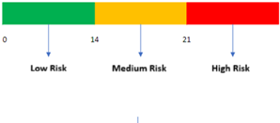**The Primary Goal is** to **help the Participant to reduce their alcohol intake to less than 14 units**. This will be achieved through the Participant deciding on how many days to go drink-free and drinking in smaller amounts (fewer units or drinks with less alcohol).

## **The Traffic Light System in ENHANCE**

We have included a traffic light style alert system in the app to indicate a warning level which is an indication of the level of concern raised for the corresponding alcohol intake benchmark, as shown in the diagram below.

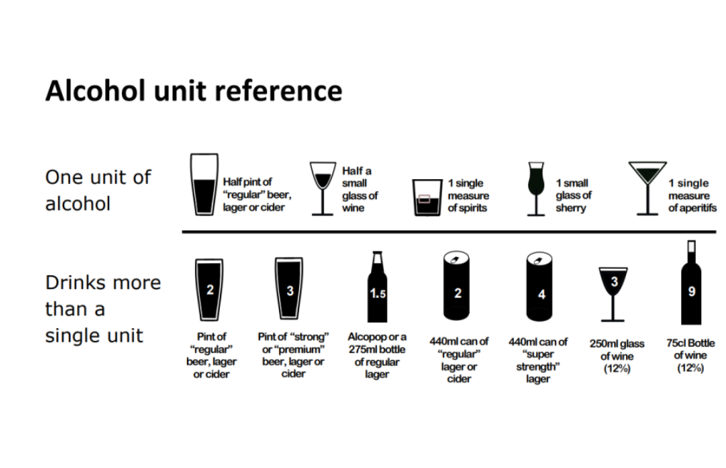

# **The Coaching Role: Drinking Less**

* Throughout the intervention, you will guide the Participant to record the days of the week they will go drink-free and complete the weekly check-ins on the app.
* You will help the Participant identify reasons and triggers for drinking, and motivations for reducing drinking.
* You will help the Participant transition into drinking less by making commitments and resolving barriers.

## **App Content: Drinking Less (for reference)**

Each week, the Participant will be encouraged to report how many days in the coming week they will keep drink-free, play some of the games, and watch two videos every fortnight.

|  |  |
| --- | --- |
| Getting Started | * A bottle and glass of alcohol    Description automatically generatedAlcohol and the brain * Understanding units * Benefits of cutting down * What to expect from the module * NHS videos of cutting down * Personal story (Frank) |
| Understanding Units | * A screenshot of a game    Description automatically generatedIntroducing **weekly** **limit** * What does **14 units** of alcohol look like * Short term **benefits** of alcohol reduction * **Tips** to stay within the recommended guidelines * **Understand** binge drinking |
| Brain Health | * A pink brain with black background    Description automatically generatedAlcohol and the brain * How the alcohol affects brain- directly and indirectly * Alcohol and **dementia** link * Benefits of drinking less |
| Body Health | * A heart with arms and a smile    Description automatically generatedAlcohol and **weight** * Alcohol and risk of cerebrovascular **diseases** * How alcohol affects brain and blood vessels * How can reducing drinking can help keep the brain and body healthy * **Calories** in alcohol * Healthy choices * Reminder to do check-in questionnaires |
| Mental Health | * A head with different colored circles    Description automatically generatedClose link of alcohol and mental health * How drinking can make you **feel** * Alcohol and how it affects **sleep** * **Cutting** **back** can help mental health * Dr. Jarvis shares tips |
| What to do Next | * Practical tips to reduce alcohol intake * Signposting on where to get more advice * Summary of the key points and encouragement |

# **Drinking Less: Session 1 (30-60 minutes)**

**🧠 Meeting Preparation:** Read the **Participant activity report that the ENHANCE core team will send you.** In many cases the Participants will not have recorded readings, that’s OK.

## **Check-In & Review (10-15 minutes)**

**Participant has been asked in App:**

**[Week 1] –** “*Are you ready to cut down your drinking?”*

* *“Why do you want to drink less?”*
* *“When do you feel you want to drink?”*

**[Week 1-7] -** *“How many days next week will you keep drink-free?”*

* + ✔️ **If the Participant has completed the check-in:** Discuss if the Participant was able to stick to their check-in answers. If not, discuss barriers and future steps.
  + ❌ **If the Participant hasn’t completed the check-in or used the app:** Offer support and troubleshoot any issues

## **Discussion on Alcohol Intake (20 minutes)**

💬 Open Conversation about Understanding of Alcohol Intake

* + Encourage the Participant to talk about what they saw in the video. Give them space to share thoughts, insights, or concerns.

📌 Key Points to Address

*Even if the Participant doesn’t bring it up, make sure to cover these* ***critical points****:*

* **Alcohol accelerates cognitive decline: “***Drinking less can help protect your memory and reduce the risk of dementia.”*
* **Your body handles alcohol differently as you age: “***Even small amounts can have a bigger impact on your brain.”*
* **Feeling better overall*:*** *“Cutting back on alcohol can improve your sleep, energy, and health, keeping your mind sharper.”*

 🔍 Reflect on Reasons for Drinking and Goal Setting

* The Participant is invited to think about the reasons for their drinking and set goals to reduce drinking.

⚠️ Introducing ‘Triggers’

* This involves asking the Participant to think about their triggers or antecedent behaviours of drinking.

🚀 Assess Motivation and Barriers

* **Explore and tackle any emotional or practical challenges** that may have surfaced. Try to solve them.

## **3. Set 1-3 Goals - Drinking Less (15-20 minutes)**

🎯 Introduction to Goal Setting *Encourage the Participant to take the lead, ask them to set up to three goals to work on over the next few weeks for reducing their alcohol consumption*

* + Ensure the goals are **SMART** and personalised to the Participant’s readiness and motivation.

💡 Example of **SMART** Goals: Offer some suggestions, but ensure the Participant has the final say:

|  |  |  |  |  |  |
| --- | --- | --- | --- | --- | --- |
| **Goal Type** | **Specific** | **Measurable** | **Achievable** | **Relevant** | **Time-bound** |
| **Alcohol reduction** | Limit alcohol to no more than 4 drinks per week | Track drinks consumed using an app or journal. | Set reminders for alcohol-free days. | Reduces risk of dementia and improves overall health. | Over the next 2 weeks. |
| **Replacing Alcohol** | Replace alcohol with non-alcoholic drinks 3 times a week. | Count and log alcohol-free days. | Plan social activities with non-alcoholic options. | Helps maintain the habit of drinking less. | For 4 weeks, then review progress. |

**Checking Goal Confidence (Achievable)**: IF the Participant is struggling with motivation, ask:

"On a scale of 1-10, how confident do you feel about achieving this in the next two weeks?"

1 = Not at all confident

10 = Extremely confident

🌟 Aim for 7-8: Challenging but achievable!

## **4.Closing and Next Steps (5 minutes)**

🔑 Briefly recap the key points and schedule the next session for two weeks’ time. ***Be flexible if two weeks does not work and Participant needs weekly support.*** Remind them they can reach out via the app if needed.

**COACH ACTION: Record Information from Session in SealedEnvelope**

****During or after the session, you will need to enter **valuable data about the Coaching session with the Participant**, such as goals, any challenges, time and date of the session, etc.

**Log In to SealedEnvelope Here**

[**SealedEnvelope.com/access**](http://www.sealedenvelope.com/access/)

*Press CTRL + click the link with the mouse to open*

**End of Drinking Less Session 1.**

# **ShapeDrinking Less Session 2 & 3 – Progress Check (~30 minutes)**

## **Review the Participant’s Progress**

* + 🎯 **Goal Review:** Reflect on the goals from Session 1, highlighting successes, discuss obstacles, and adjust goals if needed.
  + 📱 **App Usage:** Review app engagement, including watching videos.
  + **Praise** any engagement and offer help if they faced challenges using the app.

## **Problem-Solving:**

* 💡 **Address Issues:** Ask about any challenges and offer solutions.
  + **Example actions**: Assist with app navigation.
  + ***Reassurance:*** *Emphasise that challenges are part of the process and can be managed.*

## **Next Steps:**

* ⚡**Highlight Impact:** Emphasise the long-term benefits of reducing alcohol consumption.
* ⏩ After Session 3: **Prepare for transition** to the next risk factor.
* 🎉 **Positive Reinforcement:** *Celebrate achievements***,** even if small, and highlight how these changes impact overall health.

**COACH ACTION: Record Information from Session in SealedEnvelope**

****During or after the session, you will need to enter **valuable data about the Coaching session with the Participant**, such as goals, any challenges, time and date of the session, etc.

**Log In to SealedEnvelope Here**

[**SealedEnvelope.com/access**](http://www.sealedenvelope.com/access/)

*Press CTRL + click the link with the mouse to open*

**End of Drinking Less Intervention.**

Additional Notes for Coaches:

* 🎉 **Celebrate efforts:** Use this session to recognise the Participant’s hard work, even if all goals were not met.
* 🏃‍♂️ **Emphasise long-term effort:** Reinforce that reducing alcohol consumption is an ongoing process.
* 🔄 **Flexibility in progress:** Acknowledge that everyone moves at their own pace. The Participant should feel comfortable with where they are in their journey.



1. **Meeting People Intervention**

At this point, the Participant has chosen Meeting People as the intervention to focus on.

# **Overview of Meeting People Intervention in ENHANCE**

**The Primary Goal:**

* To encourage Participants to meet people and increase social connections online or in-person.
* To help Participants understand the importance of maintaining social connections and the benefits that meet people can have on their well-being.
* This will be achieved through the **“Meeting People” weekly videos**, which provide knowledge about social connections, along with Coach support in joining the **ENHANCE WhatsApp group or local groups** through SimplyConnect.

## **The Coaching Role: Meeting People**

* From Week 1, you will encourage Participants to engage in **conversations in the ENHANCE WhatsApp group,** or with their friends and family.
* **The Participant will have nominated a family member or friend to be involved.**
* **⚠️ You will encourage participants to join the WhatsApp group, however, as their coach, you will not join nor view their discussions.**

## **App Content: Meeting People (for reference)**

|  |  |
| --- | --- |
| Getting Started | * Social connections benefits for mood, brain health & quality of life. * Mary’s personal story. * Suggestions for meeting people: talk to neighbours, use technology, join local events, or volunteer. |
| Where to Meet Them? | * Importance of friendships. * Using online tools (SimplyConnect, Time2Volunteer, Live Well Hull). * How to use WhatsApp voice messages to stay in touch with loved ones. |
| Doing Things with Others | * Local activities (book clubs, walking groups, and community events). * Small interactions (e.g., saying hello) build networks. * Social connections improve health and brain sharpness. |
| John's Story | * John’s story: From isolation to making friends through ENHANCE. * Resources like SimplyConnect for finding local activities. |
| Health Benefits | * Social connections reduce cognitive decline risk and support brain health. * Quality relationships are essential for mental well-being. |
| What to Do Next? | * Support from organisations (Age UK, The Silver Line). Faith groups and community centres for events. * Asking for help is key to staying connected. |



# **Meeting People: Session 1 (30-60 minutes)**

**🧠 Meeting Preparation:** Read the **Participant activity report that the ENHANCE core team will send you.** In many cases the Participants will not have recorded readings, that’s OK.

## **Check-In & Review (10-15 minutes)**

**Participant has been asked in app***: “In the last week, how often did you chat to or do something enjoyable with friends or family (0-7 days)?”*

* ✔️ **If the Participant has shared their social contact/has joined the WhatsApp group:** Discuss what they did and how they felt; encourage them to introduce themself, start conversations and share interests or social events ideas.
* ❌ **If the Participant hasn’t shared their result yet:** Encourage them to do so and troubleshoot any difficulties.

## **Discussion on Meeting People (20 minutes)**

💬 Open Conversation about Understanding of Social Connections:

* + Discuss Week 1 video (watch it with them if they haven’t). Encourage the Participant to reflect on what they’ve learned so far. Give them space to share thoughts, insights, or concerns.
  + Encourage the Participant to engage in the WhatsApp group, explore local activities that align with their interests and schedule regular meetups to maintain relationships.

📌 Key Points to Address

*Even if the Participant doesn’t bring it up, make sure to cover these* ***critical points****:*

* **Lack of Awareness:** *“Social connections can enhance well-being in ways we might not always notice. Meeting with others regularly can uplift your daily life, even when things seem fine.”*
* **Ongoing Engagement:** *“Even if you feel comfortable on your own sometimes, maintaining regular social interactions is crucial for your mental and physical well-being over time.”*
* **Consistency in Socialising (if relevant):** *“Regularly engaging with others, even in quieter moments, helps you stay confident and prepared for more social activities.”*

🛑 Assess Motivation and Barriers

* **Explore and tackle any emotional or practical challenges** that may have surfaced.

📈 Assess Readiness for Change

* + - **Example:** *“What do you think is the next step for you?”*

## **Set 1-3 Goals – Meeting People (15-20 minutes)**

🎯 *Encourage the Participant to take the lead, ask them to set up to three goals to work on over the next few weeks to boost their social connections.*

* Ensure the goals are **SMART** and personalised to the Participant’s readiness and motivation.
  + *“It’s important these goals fit into your daily life and feel achievable. We can adjust them if needed.”*

💡 **SMART** Goals: Offer some suggestions, but ensure the Participant has the final say:

|  |  |  |  |  |  |
| --- | --- | --- | --- | --- | --- |
| **Goal Type** | **Specific** | **Measurable** | **Achievable** | **Relevant** | **Time-bound** |
| **ENHANCE WhatsApp Group** | Send a message in the group to start conversations with other Participants. | Send at least one message. | Start with some opening phrases, such as “The weather has been lovely lately.” | People in the ENHANCE WhatsApp group might suggest a meetup locally. | Over the next 1 week. |
| **Social Activities/**  **Groups** | To join some local community activities that you may enjoy. | Register for an activity within the next 7 days. | Search for activities you may enjoy and confirm the date. | Talk to your Coach if you have any difficulties navigating the websites. | Over the next 3 months. |

*“These are just ideas—what do you think? Are there any other goals you’d like to set?”*

**Checking Goal Confidence (Achievable)**: IF the Participant is struggling with motivation, ask:

"On a scale of 1-10, how confident do you feel about achieving this in the next two weeks?"

1 = Not at all confident

10 = Extremely confident

🌟 Aim for 7-8: Challenging but achievable!

## **Closing and Next Steps (5 minutes)**

🔑 Briefly recap the key points and schedule the next session for two weeks’ time. ***Be flexible if two weeks does not work and the Participant needs weekly support.*** Remind them they can reach out via the app if needed.

**COACH ACTION: Record Information from Session in SealedEnvelope**

****During or after the session, you will need to enter **valuable data about the Coaching session with the Participant**, such as goals, any challenges, time and date of the session, etc.

**Log In to SealedEnvelope Here**

[**SealedEnvelope.com/access**](http://www.sealedenvelope.com/access/)

*Press CTRL + click the link with the mouse to open*

**End of Meeting People Session 1.**

# **Meeting People: Session 2 & 3 - Progress Check**

## **Review the Participant’s Progress**

* 🎯 **Goal Review:** Reflect on the goals from Session 1, highlighting successes, discuss obstacles, and adjust goals if needed.
* 📱 **App Usage:** Review app engagement, including watching videos.
  + **Praise** any engagement and offer help if they face challenges increasing social interactions or finding local activities.

## **Problem-Solving:**

* 💡 **Address Issues:** Ask about any challenges and offer solutions.
  + *“What challenges have you faced in reaching out or engaging with others in social activities?”*
  + *“Have you been able to take any steps toward meeting people either online or face to face?”*

## **3. Next Steps:**

* ⚡**Highlight Impact:** Emphasise the long-term benefits of social connection on brain health.
* ⏩ After Session 3: **Prepare for transition** to the next risk factor.
* 🎉 **Positive Reinforcement: Celebrate achievements,** even if small
* 💡 **Continued Progress:** Emphasise that the Participant can still **maintain social interactions and activities** as they move on to the next area of focus.

**COACH ACTION: Record Information from Session in SealedEnvelope**

****During or after the session, you will need to enter **valuable data about the Coaching session with the Participant**, such as goals, any challenges, time and date of the session.

**Log In to SealedEnvelope Here**

[**SealedEnvelope.com/access**](http://www.sealedenvelope.com/access/)

*Press CTRL + click the link with the mouse to open*

**End of Meeting People Intervention.**

Additional Notes for Coaches:

* 🏃‍♂️ **Emphasise long-term effort:** Reinforce that increasing social interactions is an ongoing process.



1. **Better Mood Intervention**

At this point, the Participant has chosen the Better Mood intervention to focus on.

# **Overview of Better Mood Intervention in ENHANCE**

**The Primary Goal:**

* To improve mood, make life better and enhance brain health.
* The intervention involves **Behavioural Activation (BA)** which is a practice approach to improve mood by increasing positive, enjoyable activities, such as socialising, hobbies and leisure activities.

By introducing meaningful activities, we can break these cycles!

## **Intervention Components & The Coaching Role:**

* **Self-Monitoring Mood:** The Participant answers a weekly question: *“How would you rate your mood now? (0 – 10)”.* As a Coach, encourage them to think about which activities have helped their mood
* **Weekly activity ideas (Educational Videos):** Each week, the videos suggest ideas for three activities to engage in to improve mood and provides information about low mood and the symptoms.
* **Coaching:** You will motivate the Participant to choose and complete activities that they are not doing already. The suggestions in the videos are graded, from simple to complex. The Participant should be encouraged to keep doing the activities they enjoy and slowly add in more.
* Help the Participant to record their mood in the app and highlight the link between their mood and the activities they engage in.
* Offer guidance on using app features, like the tap-and-slide function to record their mood.

## **App Content: Better Mood (for reference)**

|  |  |
| --- | --- |
| Getting Started | Topic: What is Depression or Low Mood?  Focus: Introduce the module & explain its different parts  Weekly ideas:   * Get some sun or light * TV time out * Self-care time (e.g. tea break)   Story: Hannah’s Story |
| Getting Active | **Topic:** What is Behavioural Activation?  **Focus:** Explain behavioural activation & its benefits  **Weekly ideas:**   * Make your bed * Easy stretch session * Neighbourhood stroll   **Story:** Raj’s Story |
| Self-Care | **Topic:** What is Self-Care?  **Focus:** Ways you can take care of yourself  **Weekly ideas:**   * Take a shower * Eat a proper meal * Gratitude journal   **Video:** Problem-solving NHS video |
| Positive Thinking | **Topic:** The Effects of Low Mood  **Focus:** Encourage positive thinking  **Weekly ideas:**   * Be kind to yourself (Positive affirmation) * Mindful nature walk * 5-minute meditation   **Video:** Tackling worries NHS video |
| Where to Get Help | **Topic:** Seeking Support and Understanding Available Resources  **Focus:** Where and how to find help  **Weekly ideas:**   * Share a special meal * Group exercise fun * Take personal time   **Video:** Reframing unhelpful thoughts NHS video |
| What to do Next? | **Topic:** Recap of the Better Mood module  **Topic:** Review progress and lessons learned  **Weekly ideas:**   * Sweat session * Try something new * Community involvement   **Video:** Bouncing back from life’s challenges NHS videos |

Each week, Participants will be encouraged to play cognitive games, record their mood, engage with one video, and complete at least one activity.

# **Better Mood: Session 1 (30-60 minutes)**

**🧠 Preparation:** Read the **Participant activity report that the ENHANCE core team send you.**

## **Review Participant’s Progress:**

**Review what activities the Participants did last week** and ask **how they felt** after completing the activity. If Participants didn’t complete any activity, ask them how that made them feel.

## **Check-In (10-15 minutes)**

**Participant has been asked in App:** *“How would you rate your mood now? 0 is the worst, 10 is the best.”*

* ✔️ Discuss the recorded reading and if it is gone down or up relative to the previous week. Discuss with Participants which activities could improve their mood for next week.
* ❌ **Participant hasn’t recorded their mood or played any games/watched any videos:** Ask what got in their way and to think through and troubleshoot any issues.

## **Discussion on Better Mood (20 minutes)**

📌 Key Points to Address: Let the Participants start the conversation, but if the Participant doesn’t bring it up, be sure to cover these key points

* **Low Mood and Motivation***: “Once you start, it gets easier. When people feel low, they think they have to wait until they feel motivated to start the activity. But the motivation comes after starting the activity.”*
* **Engaging in Activities:** *“Taking even small steps can help. The activities suggested in this module are designed to help you get started and feel better.”*
* **Ongoing Progress:** *“Remember, progress might be slow at first, but sticking with the* activities *over time can lead to improvements in your mood.”*

🛑 Assess Motivation and Barriers: Explore any emotional or practical challenges that may have surfaced.

* It’s common for people with low mood to struggle with motivation. Here are some examples Participants might relate to, along with helpful ways to address them:

## **Set goals: 1-3 Activities for Better Mood (15-20 minutes)**

🎯 *Encourage the Participant to take the lead, ask them to set up to three goals to work on over the next few weeks for managing their mood.*

* Ensure the goals are **SMART** and personalised to the Participant’s readiness and motivation.
  + *“It’s important these goals fit into your daily life and feel achievable. We can adjust them if needed.”*

💡 Example of **SMART** Goals Offer suggestions, but ensure the Participant has the final say:

|  |  |  |  |  |  |
| --- | --- | --- | --- | --- | --- |
| **Goal Type** | **Specific** | **Measurable** | **Achievable** | **Relevant** | **Time-bound** |
| **Try a Relaxation Activity** | Practice a relaxation technique, such as deep breathing, for 5 minutes. | Record the details of how you felt before and afterwards. | Five minutes is a short time period & you can decide when to do it. | Helps reduce stress and improves mood | Do it at least once a week for next two weeks, |
| **Engage in One Outdoor Activity** | Go for a 10-minute walk outside at least twice a week. | Keep track of each walk by noting it in down on paper after completion. | Manageable because it can be down at your own pace & time. | Outdoor activity can boost mood and energy. | Complete this activity at least twice weekly. |
| **Weekly Mood Check-In** | Record your mood | Use the app to track your mood for the next two weeks. | This can be done in just a couple of minutes and requires minimal effort. | Helps you identify how activities impact your mood | Track mood weekly for next two weeks |

*“These are just ideas—what do you think? Are there any other goals you’d like to set?”*

**Checking Goal Confidence (Achievable)**: IF the Participant is struggling with motivation, ask:

"On a scale of 1-10, how confident do you feel about achieving this in the next two weeks?"

1 = Not at all confident

10 = Extremely confident

## **Closing and Next Steps (5 minutes)**

🔑 Recap the key points and schedule the next session for two weeks’ time. ***Be flexible if the Participant needs weekly support.*** Remind them they can reach out via the app if needed. **COACH ACTION: Record Information from Session in SealedEnvelope**

****During or after the session, you will need to enter **valuable data about the Coaching session with the Participant**, such as goals, any challenges, time and date of the session, etc.

**Log In to SealedEnvelope Here**

[**SealedEnvelope.com/access**](http://www.sealedenvelope.com/access/)

*Press CTRL + click the link with the mouse to open*

# **Better Mood: Session 2 & 3 – Progress Check (~30 minutes)**

## **Review the Participant’s Progress:**

* 🎯 **Goal Review:** Reflect on the goals from Session 1, highlighting successes, discuss obstacles, and adjust goals if needed.
* 📱 **App Usage:** Review app engagement, including watching videos.
  + **Praise** any engagement and offer help if they faced challenges using the app.

## **Problem-Solving:**

* 💡 **Address Issues:** Ask about any challenges and offer solutions.
  + **Example actions**: Discuss their mood, assist with app navigation.
  + ***Reassurance:*** *Emphasise that challenges are part of the process and can be managed.*

## **3. Next Steps:**

*  **Positive Lifestyle Changes:**
  + Discuss any changes the Participant has made based on the various behavioural activities completed over the course of the module, such as physical activity, self-compassion, reflection, and self-care.
* ⏩ After Session 3: **Prepare for transition** to the next risk factor.
* 🎉 **Positive Reinforcement:**
  + **Celebrate achievements,** even if small, and highlight how these changes impact blood pressure.
  + 💡 **Continued Monitoring:** Emphasise that Participants can still **monitor their mood** as they move on to the next area of focus.

**COACH ACTION: Record Information from Session in SealedEnvelope**

During or after the session, you will need to enter **valuable data about the Coaching session with the Participant**, such as goals, any challenges, time and date of the session, etc.

**Log In to SealedEnvelope Here**

[**SealedEnvelope.com/access**](http://www.sealedenvelope.com/access/)

*Press CTRL + click the link with the mouse to open*

**End of Better Mood Intervention.**

**Next Steps For Post-Intervention**

This is your final meeting with your participant as they have reached the end of the coaching intervention for ENHANCE

**🤝 Thank your participant**

* Thank your participant for their dedication and commitment over the past 3 months.
* Explain that we value their participation and their efforts throughout the study.
* Give praise for making positive lifestyle changes.

**❔Provide time for questions**

Before you conclude, does your participant have any questions?

E.g.

* The program or anything you’ve covered together
* Using the app going forward
* Any of the resources or strategies

**⬆️ Continuing their journey**

Would your participant like to continue using the intervention app on the tablet?

**If yes:**

* **The tablet is theirs to keep!**
* They can continue accessing all the app features and resources

Note: SIM connectivity will continue only until the feasibility study is completed for everyone involved.

**▶️ Moving Forward**

Encourage the participant to:

**✓** **Continue practicing their behaviour change strategies**—explain that the habits they've built are the key to lasting change

**✓** **Explore the app library regularly**—there are videos, games, and other resources designed to support their continued progress

**✓** **Continue setting SMART goals**—highlight that carrying on with the SMART framework, they will continue to achieve results.

**✓ Revisit materials whenever they need**—the tools and information are there for them, anytime

**👋 A final best wishes**

Thank your participant again for allowing us to be part of their journey to lasting change.

# **Appendix**

|  |  |  |
| --- | --- | --- |
| Section | | Page |
| 1 | **Script Suggestion for Sessions** | 78 |
| 2 | **Additional Information for ENHANCE Risk Factors** | 84 |
| 2.1 | Behavioural Activation List | 84 |
| 2.2 | Additional SMART goals suggestions | 85 |
| 2.3 | Helpful GROW Coaching Questions to Problem-Solve | 93 |
| 3 | **Health Status Summary** | 94 |
| 4 | **Frequently Asked Questions (FAQs)** | 95 |
| 5 | **Goal Setting Template** | 97 |
| 6 | **Quit Plan Template** | 98 |
| 7 | **Participant Guide to ENHANCE Sessions** | 99 |
| 8 | **Coaching Role Flow** | 100 |

**Session 1 (30-60 minutes) – Script Suggestions**

**Objectives:**

* 📈 **Review Participant Progress:** Discuss what’s going well and any difficulties with using the app or the devices for each risk factor. Collaborate to address any challenges.
* 🔍 **Explore COM-B Factors:** Use targeted questions to assess **Capability, Opportunity, and Motivation** for managing the risk factor.
* 🎯 **Set 3 Personalised Goals:** Establish three tailored goals for managing the risk factor.

**Coach Preparation for Session:**

🖥 Review Participant’s App Usage:

* Check the Participant’s activity in the app via the **Dashboard** (see Figure 1).
* Look at any data they’ve collected (e.g., **blood pressure readings**)

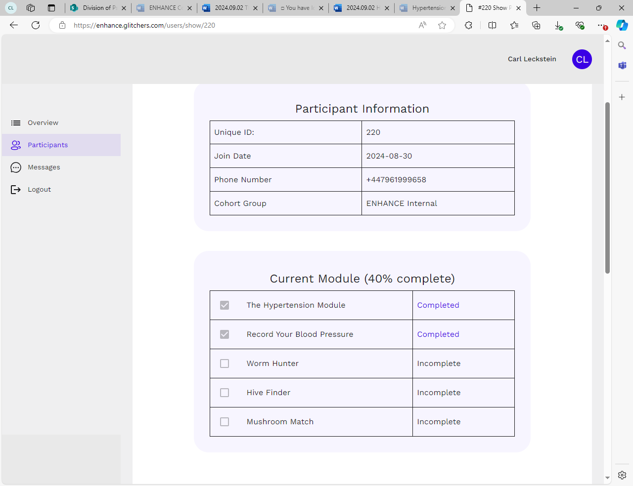

Figure 3. Participant App Usage Summary on Dashboard

**Check-In and Review**

📝 Check-In:

Acknowledge their app activity or any outside efforts since the last session.

* **Example:** *“Well done on meeting today! It’s great to see you staying engaged! How did you get on since we last met?”*

📈If Activity is Logged:

* **Acknowledge progress positively.** For example:
  + “I see you’ve played a game. Great job!”
  + “You’ve logged your blood pressure readings. Well done!”

🔧 If No Activity is Logged:

* ❌ **Participant hasn’t recorded their blood pressure or played any games/watched any videos:** **Offer support and troubleshoot** any issues
  + **Coach response:** *“I noticed you haven’t logged your blood pressure this week. What do you think got in the way, or would it help if we went over the process again?”*

***Coach Note:***

**🧠** Participants are **more likely to engage** in a behaviour if they know the Coach will review their progress. Use positive reinforcement and show interest in their achievements.

**Discussion on Risk Factor (20 minutes)**

🎬 Content Review

* ❌**Participant hasn’t watched the video:** *“Would you like to watch the video now?”*

🧠 Open Conversation about Understanding of Risk Factor:

* + Encourage the Participant to reflect on what they’ve learned so far. Give them space to share thoughts, insights, or concerns.
    - **Example**: *“We talked about high blood pressure in the set-up meeting and the video introduced the topic to you. What stood out to you from that conversation or the video? Has your understanding become clearer?”*

🛑 Assess Motivation and Barriers

* **Explore any emotional or practical challenges** that may have surfaced:
  + *“Have you encountered any challenges that make managing your (risk factor) difficult?”*
  + *“What might make it easier for you to stay on track with your goals? “*
* If Participant struggles with motivation and says something like *“I can’t even get started!”* or *“I don’t have the motivation,”* offer reassurance and insights into how they can start on the journey and take sustainable steps towards getting more motivated.
* *“When you’re feeling low, it’s completely normal to struggle with finding the energy to begin even simple tasks.”*
* *“The good news is, once you take that first step and start an activity, motivation often begins to build.”*
* *“Starting is often the hardest but most important part! Once you start, you will gain momentum, and it will keep getting easier with time.”*

📈 Assess Readiness for Change

* + - **Example:** *“Based on what we’ve discussed, do you feel more or less ready to make changes to manage your blood pressure?”*

**Set 3 Tailored Goals - Specific to Risk Factor (15-20 minutes)**

🎯 Introduction to Goal Setting: *Encourage the Participant to take the lead:*

* **Example:** *“Now that we have talked about how things are going, let’s set up to three goals to work on over the next few weeks to help manage your blood pressure. Based on what you’ve learned so far, what do you think would be some realistic and helpful goals?”*

🙋 Participant-Centred Approach: *Empower the Participant to personalise the goals or suggest their own.*

* Ensure the goals are **SMART**
* Personalise the goals to the Participant’s readiness and motivation levels:
  + *“It’s important these goals fit into your daily life and feel achievable. We can adjust them if needed.”*

**Specific** – you know exactly what you want to do

**Measurable** – you can track progress

**Achievable** – you can really do it (think COM-B)

**Relevant –** it’s impotant to them to do

**Time-bound** – There is a deadline to complete the goal by.

*“These are just ideas—what do you think? Are there any other goals you’d like to set?”*

**Closing and Next Steps (5 minutes)**

🔑 Recap Key Points

Briefly review the session’s highlights, focusing on the Participant’s progress and goals.

* *“We’ve set some important goals today—daily blood pressure monitoring, scheduling a GP appointment, and staying engaged with the app. Does that sound good?”*
* If relevant: *“We’ll send* ***an update to your nominated family/friend member****s, letting them know about the goals we’ve set today, so they can support you in sticking with them.”*

📅 Next Session:

Schedule the next session for two weeks, focusing on continued progress and troubleshooting.

* *“Let’s meet again in two weeks to see how things are going.”*

📲 Support:

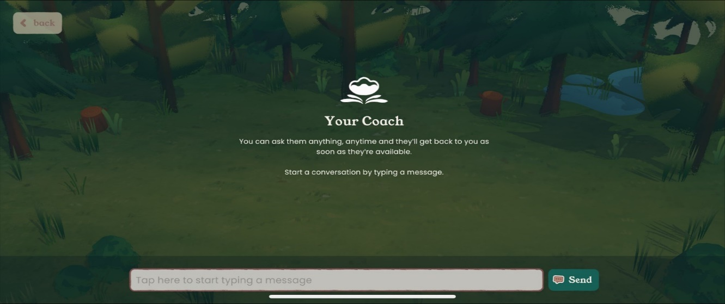

Figure 4. The messaging feature in the app

Remind the Participant they can reach out via the app if needed (see Figure 4.)

**Example: “**If you have any questions before then, feel free to message me through the app.”

💪 Encouragement: End on a positive note and leave the Participant feeling motivated and supported:

**Example:** “You’re doing great, and let’s keep up the great progress!”**Session 2 and 3 – Progress Check**

**Objectives:**

* 📈 **Progress Check:** Check in on the Participant’s progress app engagement, and progress towards their goals.
* 🎥 **Video Review:** Discuss the **Week 2** and **Week 3** video content.
* 🧠 **Coaching Support:** Coach continues to support the Participant, involving goal setting, reflection, discussing obstacles and encouragement.

**Review the Participant’s Progress**

* 🎯 **Goal Review:**
  + Reflect on the goals from Session 1, highlighting successes and discussing any obstacles.
  + If needed, adjust the goals based on challenges. Focus on making them realistic & achievable.
* 📱 **App Usage:**
  + Review app engagement, including watching Week 2 and Week 3 videos.
  + **Praise** any engagement and offer help if they faced challenges using the app.

**Problem-Solving:**

* 💡 **Address Issues:** Ask about any challenges and offer solutions.

**Example actions**: Demonstrate the blood pressure monitor again, assist with app navigation.

* **Ask Open-Ended Questions:**
  + *“What challenges have you faced in speaking with your GP?”*
  + *“Have you been able to incorporate more physical activity?”*
* ***Reassurance:*** *Emphasise that challenges are part of the process and can be managed.*

**Next steps:**

* 🍎 **Watch Week 4** and **Week 5** videos.
* ⚡**Highlight Impact:** Emphasise the long-term benefits of diet and lifestyle changes on risk factors.
* **📅 Book the next session** in 2 weeks to review further progress and discuss the next steps.

**End of Session 2 & 3.**

**Next Steps: Transition to the Next Risk Factor**

To transition Participants smoothly to the next risk actor, it’s important to acknowledge their progress in managing the current risk factor while introducing the new focus. Here is a suggested guide on how to support Participants through this transition:

* 🌟 **Acknowledge progress** in managing the current risk factor and introduce the next risk factor.
* 📅 **Upcoming Sessions:** Explain the focus will shift to the new risk factor, but **current risk factor goals remain** and can be revisited at any time.
* **Introduce the Next Risk Factor:**
  + *“Our next focus will be on [second risk factor chosen]. Just like with (current risk factor), we’ll set some goals and work though strategies to address this area.”*
* **Encourage Long-Term Focus on current risk factor:**
  + “*Managing (current risk factor) is a long-term commitment, so while we’re shifting focus, don’t hesitate to reach out if you need more support or feel like revisiting your (current risk factor) goals.”*

# **Additional Information for ENHANCE Risk Factors**

## **2.1 Behaviour Activation List**

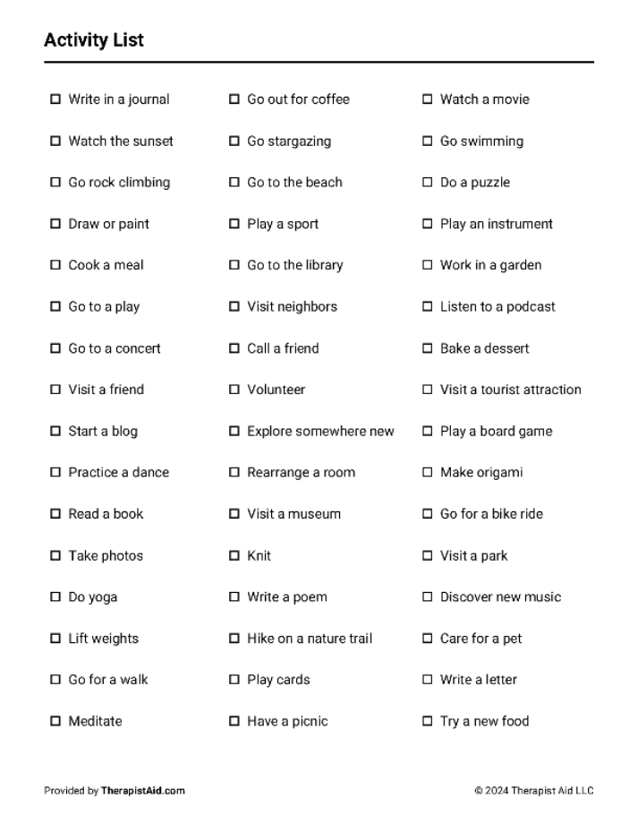

## **2.2 Additional SMART Goals Suggestions**

**Managing Blood Pressure**

|  |  |  |  |  |  |
| --- | --- | --- | --- | --- | --- |
| **Goal Type** | **Specific** | **Measurable** | **Achievable** | **Relevant** | **Time-bound** |
| **Reduce salt intake to 2,000 mg per day.** | Limit salt consumption by choosing lower-sodium options and avoiding adding extra salt to meals. | Track salt intake using a food diary or app. | Start by reducing high-salt foods gradually. | Reducing sodium helps lower blood pressure. | Achieve within 2 weeks, then continue for ongoing management. |
| **Diet** | Include vegetables in every meal (e.g., spinach in breakfast, salad at lunch). | Track servings using a food log or app. | Start by adding a serving of vegetables to one meal and increase gradually. | A vegetable-rich diet helps control blood pressure by providing necessary nutrients and fibre. | Complete the goal daily for the next 4 weeks |
| **Exercise** | Engage in moderate physical activities like walking, cycling, or swimming. | Track exercise sessions using a fitness app or journal. | Can start with shorter sessions and gradually increase. | Regular exercise helps lower and manage blood pressure. | Exercise 4 times per week for the next 6 weeks. |

**Managing Blood Sugar**

|  |  |  |  |  |  |
| --- | --- | --- | --- | --- | --- |
| **Goal Type** | **Specific** | **Measurable** | **Achievable** | **Relevant** | **Time-bound** |
| **Reduce sugary snacks** | Cut down on high-sugar foods by limiting sugary snacks to no more than twice per week. | Keep track of sugary snack consumption in a food log. | Replace sugary snacks with healthier alternatives like nuts or fruit. | Reducing sugar intake can help manage blood sugar levels and prevent spikes. | Reduce sugary snacks for 4 weeks and reassess. |
| **Prepare and plan meals for the week** | Plan and prepare meals using low glycaemic index (GI) foods like whole grains, vegetables, and legumes | Track meals prepared in advance and monitor food choices. | Use a weekly meal planner and prepare meals on weekends. | Low-GI foods help regulate blood sugar levels throughout the day. | Implement this for 3 weeks, then review progress. |
| **Practice relaxation techniques** | Set aside 10 minutes daily to engage in stress-reducing activities. | Track relaxation time using the app or a journal. | Start by incorporating relaxation during a quiet moment each day. | Stress can impact blood sugar levels, so reducing stress can help in managing diabetes. | Complete daily for the next 4 weeks, then reassess. |

**Getting Active**

|  |  |  |  |  |  |
| --- | --- | --- | --- | --- | --- |
| **Goal Type** | **Specific** | **Measurable** | **Achievable** | **Relevant** | **Time-bound** |
| **Walk to the local store** | Walk to a grocery store within manageable distance (e.g., 0.5 miles). | Track the time it takes to reach your destination. | Plan your route and pre-plan stops/breaks if you require them. | Walking increases cardiovascular and pulmonary fitness. | Attempt 2-3 times per week and assess progress – reducing number of breaks. |
| **Gardening** | Identify several gardening tasks and aim to complete them (e.g., pruning and/or weeding). | Allocate 30 minutes per day for gardening activities. | Ensure that tasks are realistic. Plan activities to suit your capabilities. | Gardening improves mental health. It can also relieve symptoms of stress. | Aim to achieve gardening activities 2-3 times per week then assess progress. |
| **Yoga (Home-based routine)** | Engage in a home-based Yoga routine (e.g., stretching, standing/seated Yoga). | Use a 30-minute Yoga video and follow the routine. | Ensure that a beginner's session is followed. Do not put yourself under stress. | Improves muscle tone, balance, and increases flexibility. | Complete 2-3 videos per week. Assess and increase level if required. |

**Social Connection**

|  |  |  |  |  |  |
| --- | --- | --- | --- | --- | --- |
| **Goal Type** | **Specific** | **Measurable** | **Achievable** | **Relevant** | **Time-bound** |
| **Meet a friend for lunch** | Arrange with a friend or family member to meet in a local cafe. | Spend 30-60 minutes having lunch and a light-hearted conversation. | Identify a quiet and less busy eatery within commutable distance from your home. | Boosts happiness, lower stress, raise your sense of connection, belonging and purpose. | After 6-8 weeks of meeting weekly, reassess and increase to two times per week. |
| **Attend cooking classes** | Identify local evening or daytime cooking classes. Aim to attend classes you’re interested in (e.g., healthy cooking, Italian cuisine etc). | Attend classes that are 30-60-minutes in duration, initially. | Join a club local to you – start at a level suitable to your skillset. | Meet new friends, improve culinary skills (helping to select and prepare healthier alternatives). | Aim to attend at least one class per week. After 6-weeks, increase if comfortable. |
| **Attend a walking club** | Find a suitable walking club for senior citizens. Ask a friend or family member to join with you – this may help with enjoyment. | Aim to attend a walking club suitable to your fitness level (e.g., 30-minutes moderate intensity to start with). | Ensure that you attend walking sessions to suit your current level of physical fitness. | Meet new people, make friends, increase physical fitness, and improve brain health. | Maintain moderate intensity walks for 6-week and assess progress. |

**Better Mood**

|  |  |  |  |  |  |
| --- | --- | --- | --- | --- | --- |
| **Goal Type** | **Specific** | **Measurable** | **Achievable** | **Relevant** | **Time-bound** |
| **Clean the house/flat** | Identify several tasks around your home and complete (e.g., hoovering, cleaning bedding, ironing, arranging your clothes). | Plan the tasks using pen and paper. Spend 30-60-minutes – tick off tasks when completed. | Ensure that tasks are manageable within allotted timeframe (e.g., X3 tasks – 20-minutes each task). | A combination of physical and mental activity, chores such as cleaning may reduce risk of developing dementia. | After 6-8 weeks, assess your progress. Implement more time-intensive tasks such as DIY if suitable. |
| **Complete leisure/fun activity** | Select a fun activity (e.g., cinema, dance class, leisure centre). | Spend 1-2 hours engaging in a fun, indoor or outdoor leisure activity. | Utilise amenities in your area – focus on something you would enjoy. | Leisure activities are key to elevating mood and lowing the risk of dementia. | Regularly assess progress – adding additional activities if/when ready. |
| **Talk to someone** | Talk to a friend or family member either via telephone, video call or in-person. | Spend at least 30-minutes per day talking to someone. | If you have a phone, call. If someone is within commutable distance, visit them. | Talking acts as a therapy which can help with low mood, depression and anxiety. | Assess and see how you feel after 6 weeks. |

**Drinking Less**

|  |  |  |  |  |  |
| --- | --- | --- | --- | --- | --- |
| **Goal Type** | **Specific** | **Measurable** | **Achievable** | **Relevant** | **Time-bound** |
| **Peer support** | Identify a local support group like (AA). | Visit the group at least once or twice per month. | Seek local support – ask a friend or family member to accompany you. | No obligation free service. Creates a network of support with complete anonymity. | After 6-8 weeks, assess its benefits. Is it helping? |
| **Inform family and friends** | Speak to one or two friends or family members. | Discuss your concerns and goals at least once a week, initially. | Seek understanding and empathic guidance. | If family and friends know about your challenges, they can provide support. | Assess the support you receive. Is it helping – gain additional support if required. |
| **Seek a GP’s advice** | Make an appointment with your local GP practice. | Visit your GP practice and ensure that their advice is actioned. | Ensure that you are registered with a GP practice. | Provides a wealth of info and free guidance – helping you to reduce alcohol consumption. | Assess the outcome – gain additional GP advice if necessary. |

**Healthy Eating**

|  |  |  |  |  |  |
| --- | --- | --- | --- | --- | --- |
| **Goal Type** | **Specific** | **Measurable** | **Achievable** | **Relevant** | **Time-bound** |
| **Drink more water** | Drink 6-8 cups or glasses of water per day. | Tick off each cup/glass of water once consumed - developing a regimented behaviour. | Ensure that you have access to clean (if possible, filtered) water, daily. | Aids metabolism, improved joints, maintains sodium (electrolyte) balance. | Assess your progress – maintain water consumption if possible. |
| **Meal prep** | Prepare your daily meals in advance – ensuring adequate consideration for ingredients. | Spend 30-minutes each day pre-planning your healthy meals. | Use the internet (if you have access) and/or recipe books. | Lose weight, prevent impulsive eating, incorporate adequate vitamins and nutrients. | Assess your progress – does this help me? Continue. |
| **Eat more high-fibre foods** | Through a natural balanced diet, consume 30g of fibre per day. | Allocate 20-30 minutes each day to identify fibre-rich foods. | Use scales, label reading, and calculations. | Lower risk of heart disease, diabetes, and improve overall health. | Check progress after 6-8 weeks. Continue if suitable. |

**Quitting Smoking**

|  |  |  |  |  |  |
| --- | --- | --- | --- | --- | --- |
| **Goal Type** | **Specific** | **Measurable** | **Achievable** | **Relevant** | **Time-bound** |
| **Discard smoking paraphernalia** | Ensure that all smoking-related items are removed from your home (put them in the bin, sell, or give them away). | Set a date - ensure that smoking-related items are removed on or before this date. | Plan a date, execute this activity on the specified date and do not delay. | Having no cigarettes or other paraphernalia in your home will help beat unwanted temptations. | Complete this task on or before your planned quit day. |
| **Seek professional advice** | Speak to a nurse and/or a quit smoking clinic. | Seek advice either prior for guidance, or after quitting smoking for support. | Call your doctor and/or identify a quit smoking clinic in your area using the internet. | Having additional support can be instrumental in succeeding when it comes to quitting smoking. | Monitor progress – seek additional support if you require it. |
| **Quit date selection** | Select a quit date that suits you (e.g., 2-3 weeks from now) - giving you time to prepare mentally. | Did you quit? (Yes/No) Make sure that your quitting date is adhered to. | Ensure that you are prepared - you have access support if required. | Reduce risk of dementia, heart disease and various forms of cancer. | Were you successful at quitting smoking? assess your achievement. |

**Better Hearing**

|  |  |  |  |  |  |
| --- | --- | --- | --- | --- | --- |
| **Goal Type** | **Specific** | **Measurable** | **Achievable** | **Relevant** | **Time-bound** |
| **Check for ear wax** | Ask a friend or family member to check your ears for wax buildup and remove if required. | Ensure that your ears are checked weekly. | Follow NHS guidance for removal (e.g., electronic ear irrigation/micro-suction) | Excessive wax can be problematic for those wearing hearing aids. | Continue for 6 week and increase/decrease checking if required. |
| **Vitamins and supplement intake** | Incorporate folic acid, magnesium, and Zinc into your diet. | Ensure that NHS guidelines are adhered to (e.g., magnesium 270mg daily for women aged 19-64). | Use off-the-shelf supplements and/or incorporate naturally into your diet. | Improve blood circulation, nerve function in the ears, support immune system – protecting cells within the ear. | Assess your progress after 6 weeks – continue if you feel good and there are no issues. |
| **Keeping ears clean - dry thoroughly.** | Make regular checks to ensure that your ears are clean, as well as dry after showering/bathing. | Check ears for dirt weekly, and ensure ears are dry after every clean. | Use a mirror to check for dirt. Dry thoroughly with a towel. | Prevent infections (e.g., Dermatitis) and potential hearing loss. | Continue for 6-8 weeks – assess your progress. |

## **2.3 Helpful GROW Coaching Questions to Problem-Solve**

|  |  |
| --- | --- |
| **Goal** | **Reality** |
| * What would you like to focus on today? * What would you like to achieve by end of today? * What’s important to you? * What would make you excited? | * What are you currently doing? * What’s getting in your way? * How do you feel about the current situation? * Is now a good time to change? * What are you saying to yourself that doesn’t help? * What will happen if you don’t change things? |
| **Option** | **Will** |
| * What would you suggest to someone else? * What could you do if you didn’t care what other people thought * What else could you do? * Let’s imagine you’ve achieved your goal what steps did you take to get there? * In a perfect world what would you do? | * How will you know you’ve achieved your goal? * What might put you off track? * What could you do to overcome these? * What can you do/use to support you? |

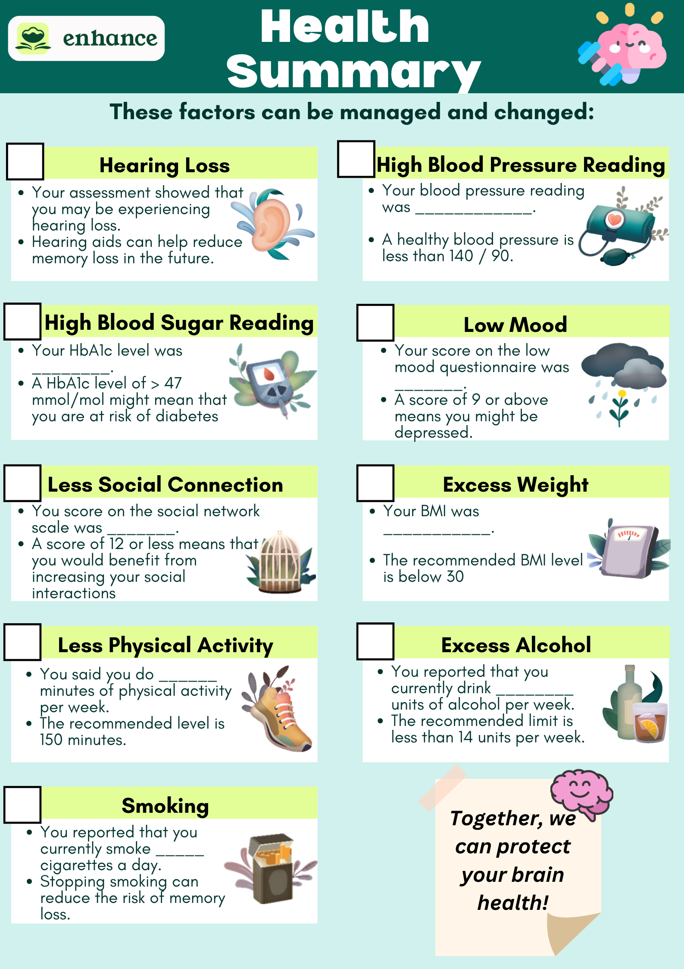

## **Shape2.4 Frequently Asked Questions (FAQs):**

Here you will find some common queries that the Participant might ask about the intervention, using the app, and their health goals.

**ENHANCE Basics:**

1. **What is the goal of this programme?**

ENHANCE helps the participant make changes to improve their brain health.

1. **What does risk factor mean?**

Risk factors such as low physical activity are things that can be changed to improve brain health.

1. **What is brain health?**

Making the brain more resilient and less likely to be damaged and reduce the risk of dementia.

1. **What is an ENHANCE Coach?**

As a Coach, your role is to support and help the participant make lifestyle changes. You will guide them through setting goals, helping them identify what motivates them, and work with them to overcome challenges.

1. **How are the risk factor modules structured?**

Each module focuses on one area and includes short videos, games, and personalised Coaching.

1. **Can my participant try to change more than three risk factors?**

It is easier to change one thing at a time. As a Coach, help your participant select three risk factors. Note: improving one risk factor often helps improve others.

1. **Why do participants focus on these risk factors for brain health?**

According to published research, these are things that can make a difference to brain health.

1. **What if the main risk factors don’t feel right to my participant?**

Sometimes health tests show areas that aren’t obvious but still need attention. Discuss this with your participant and tackle the risk factors and set goals that make sense to them.

**App Setup and Use:**

* 1. **What if my participant is having trouble with the app?**

Ask them to try closing the app and reopening it or restart the tablet by holding down the power button. If that still doesn’t work, ask them to refer to the App Guide. Remember, as their coach, you can always talk to the core team.

* 1. **What if the risk factor doesn’t change in the app, even though I’ve changed it for my participant in the database?**

Your participant might be stuck in the previous risk factor and need to log out and log back in to resolve the issue.

To do this, please follow these instructions and guide your participant.

In the meadow section of the app, tap the Watering Can (see image below).



Once you’ve tapped the Watering Can, tap the following in this order:

* 1. ***House – 2. Scissors – 3. Water drop – 4. Water drop – 5. Scissors – 6. Jar***

(see image below)

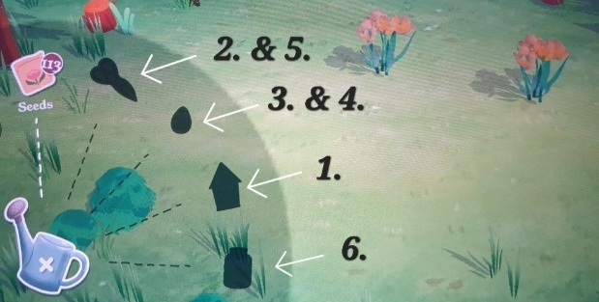

This process will log your participant out of the app. Once logged out, ask them to log back in by adding their phone number and receiving the code to their phone.

Their new risk factor should now be visible in the app.

* 1. **How do participants track progress in the app?**

On the app’s home screen, the “meadow” shows their progress. The more flowers and colours they plant, the better they’re doing! They can also tap the “Stars” button in the top right to see how many stars they’ve earned each week.

* 1. **What if my participant is experiencing technical issues with the app? For example, videos not playing correctly, poor connectivity issues, games not playing correctly.**

1. As their coach, please gain as much information from the participant as possible.
2. Ensure that you write all details about the issue in the Sealed Envelope form.
3. Bring this up in your supervision.
4. Email the core team.
5. Following guidance from core team and advise the participant.
   1. **There has been no or little app activity, what should you (their coach) do?**
6. Contact the participant as soon as possible.
7. First, understand the issue. Why has there been no activity? Do they need additional support and guidance?
8. Contact the core team for assistance.

**Goal Setting and Behaviour Change**

1. **What if my participant is not ready to make big changes?**
   * That’s okay! Small steps can make a big difference, and your participant can go at their own pace with goals that feel right for them.
2. **How can I keep my participant motivated?**
   * Remind your participant why they want to make changes. Help them set goals and celebrate their progress. Note: Remind the Participant of the family member or friend that is supporting them.
3. **What if my participant experiences a setback?**
   * Having a setback doesn’t mean starting from the beginning, it’s a part of the process. Talk about ways to get them back on track. Remember, even small changes can make a difference.
4. **How quickly should the participant see some results?**
   * Some changes you can’t see, but what they are doing is helping their brain health. Most changes will quite quickly help them feel better.

**Support and Resources**

1. **Are there additional resources available to participants for behavioural change?**

* Yes! The app videos include helpful resources, and they can find more support through the NHS, local clinics, and their GP practice.

**Scheduling and Logistics**

* 1. **What if my participant needs to reschedule a session?**
* No problem! As long as they let you know. Please reschedule another appointment.
  1. **Can my participant change goals or risk factors?**
     + Yes, they can change goals and risk factors. If they want to focus on a different area, please help and guide them. We want to encourage participants to achieve their goals, but if it’s not working, work together to find another option.

## 

## **Shape2.5 Goal Setting Template:**

These templates can be used to send the Participant a reminder of their goals set in the sessions.

**SMART Goal Template:**

* My goal: ____________________________________________________
* I want to do this because: ___________________________________
* I will do this by: ____________________________________________________
* I will track my progress by: ____________________________________________________
* My timeline is: ____________________________________________________

## **Shape2.6 Quit Plan Template:**

**My Quit Plan**

* **Quit Date:** I plan to quit smoking by ___.
* **Reasons for Quitting:** I want to quit because ___.
* **My Triggers:** Things that make me want to smoke are ___.
* **Coping Strategies:** To manage my cravings and triggers, I will ___.
* **Support Resources:** I’ll seek support from ___ (friends, family, NHS resources).

**Key Points to Remember:**

* **Long-Term Benefits:** Quitting smoking is one of the best steps for your long-term health.
* **Health Risks:** Each cigarette avoided protects your brain and reduces dementia risk.
* **Support is Available:** You’re not alone—many resources are here to help you succeed.

## **Shape2.7 Participant Guide to ENHANCE Sessions:**

This guide helps you understand what will happen in your ENHANCE sessions.

**Onboarding Session**

1. **Welcome and Introduction (5-10 minutes)**
   * Meet your Coach and learn about ENHANCE and what to expect.
2. **Review Your Health (10-15 minutes)**
   * Go over your results from the nurse.
   * Your Coach will explain the main risk factors and why they matter.
3. **Choose Your Focus (10 minutes)**

* Pick up to 3 areas (risk factors) to work on and decide which one to start with.

1. **Support and Session Dates (5-10 minutes)**
   * Discuss if a friend or family member can support you.
   * Confirm the dates of the rest of your sessions.
2. **Set Up the App (5-10 minutes)**
   * Your Coach will help you set up the app and you can explore the features.
3. **Wrap-Up and Next Steps (5 minutes)**
   * Review your chosen focus and what to do next.

**Follow-Up Session**

1. **Check-In (5-10 minutes)**
   * Talk about how things went since the last session and review your app use and progress.
2. **Discuss Risk Factor (10-15 minutes)**
   * Talk about your understanding of the risk factor and share any new thoughts or concerns.
3. **Problem Solving (10-15 minutes)**
   * Work with your Coach to solve any problems. Find ways to stay on track.
4. **Goals (5-10 minutes)**
   * Update or create new goals if needed, making sure they are SMART.
5. **Wrap-Up (5 minutes)**
   * Go over what you talked about and plan your next steps.

**Tips for You:**

* Bring any questions or notes to your session.
* Share how you’re feeling and any challenges.
* Remember: This is about making progress, not being perfect!

**8. Flow of Coaching Role:**